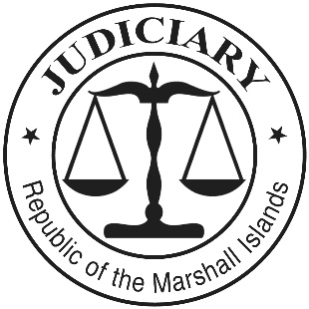
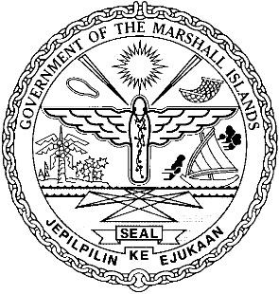

THE JUDICIARY OF THE
REPUBLIC OF THE MARSHALL
ISLANDS

2018 ANNUAL REPORT

Table of Contents
Message from the Chief Justice 1
Our Values: 2
Mission Statement: 3
Vision: 3
DEDICATION TO THE HONORABLE MILTON ZACKIOS 5
I. INTRODUCTION 6
II. SIGNIFICANT EVENTS AND ACCOMPLISHMENTS 7
A. Increase in Corporate, Maritime, and Enforcement of Foreign Judgments Cases 7
B. Ebeye Courthouse 8
C. Police Substation for Majuro Courthouse 8
D. User Satisfaction Survey 8
III. THE COURTS: EFFICIENCY, QUALITY, AND ACCESSIBILITY 9
A. Supreme Court 9
B. High Court 13
1. Civil Cases (other than Probate Cases) 14
2. Probate Cases 19
3. Criminal Cases 22
4. Juvenile Cases 26
5. Caseloads for Judges and Clerks 27
6. Selected Decisions 28
C. Traditional Rights Court 28
D. District Court 29
1. Traffic Cases (Majuro) 30
2. Criminal Cases (Majuro) 34
3. Juvenile Cases (Majuro) 36
4. Small Claims Cases (Majuro) 40
5. Caseload for Judges and Clerks (Majuro) 43
6. Ebeye 43
E. Community Courts 43
F. Travel to the Outer Islands and Ebeye 44
G. Other Services: Births, Deaths, Marriages, Notarizations, etc. 44
1. Majuro. 44
2. Ebeye. 45
H. Court Staff 45
I. Professional Development and Regional Conferences 46
J. Court Rules and Relevant Statutes 49
IV. THE JUDICIAL SERVICE COMMISSION: JUDICIAL APPOINTMENTS 50
V. ACCOUNTABILITY: CODES OF CONDUCT AND COMPLAINTS 51
VI. FACILITIES, TECHNOLOGY, AND LIBRARY 51
A. Facilities 52
B. Technology 52
C. Library 52
VII. ANNUAL BUDGET AND AUDIT REPORT 53
Appendix 1: Organizational Chart 55
Appendix 2: Judiciary Personnel 56
Appendix 3: Judiciary Fund Balance Sheets 58
Appendix 4: 2018 Assess and Fairness Survey 61

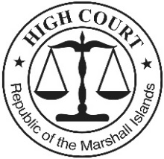
High Court
of the
Republic of the Marshall Islands

Post Office Box B
Majuro, MH 96960
Tele.: 692-625-3201
Email: Marshall.Islands.
Judiciary@gmail.com

Message from the Chief Justice

Iakwe, I am pleased to present the 2018 Annual Report for the Judiciary of the Republic of the Marshall Islands. As in past years, this report reflects the dedication and hard work of the judges and staff who serve the Judiciary, the Government, and the people of the Marshall Islands. It is my pleasure and a privilege to work with them.

On behalf of the Judiciary, I wish to express our sincere appreciation to the President, the Minister of Justice, and the other members of the Cabinet for their support in 2018. Also, I wish to express our profound thanks to the Nitijela and the House of Iroij for their continuing support of our budgetary and legislative requests. We are committed to working with the Cabinet, the Nitijela, and the House of Iroij in the years to come to maintain a judiciary that is fair and efficient, assuring justice and the rule of law for all. Our shared goals mandate that we work together in a spirit of respect and cooperation.

Submitted with the 2018 Annual Report are our updated Values, Mission Statement, and Vision Statement. For more information about the Judiciary, please contact me or the Chief Clerk of the Courts at the above address.

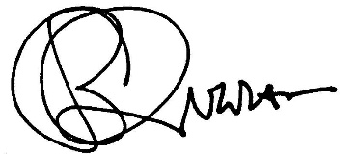
Sincerely yours,

_________________________
Carl B. Ingram
Chief Justice, High Court
Date: June 25, 2019

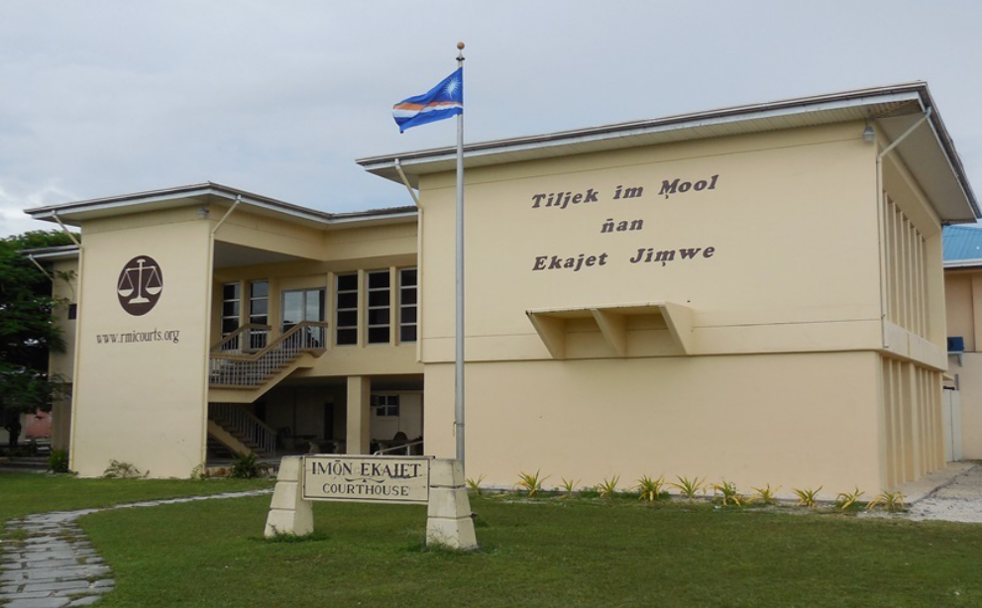

Our Values:
Tomak, Jenok, im Aurok Ko Ad:

The Marshall Islands Judiciary holds the following values and desires to operate in a manner that is, and will be perceived as:

Jikin Ekajet ko an Marshall Islands rej debij im jerbal wot iumin tomak, aurok eo,im konan eo non air jerbal ilo wawein ko renaj koman bwe armej ren kalimjeklok ra eo an Jikin Ekajet bwe ej juon eo ej einwot in:

- accessible
- accountable
- competent
- consistent
- efficient
- fair and impartial
- independent
- respectful and
- service-oriented,

- valuing custom and tradition, as well as innovation.
ebellok non aoleb armej
etiljek, ekkeke, im maron uwak non jerbal ko an
ekakemooj im emmon an komane jerbal eo an
ej jokkin wot juon an komane jerbal eo an
ebolemen im tiljek ilo an kakke aikuij ko
ej jerbal jimwe ilo ejelok kalijeklok im jeb
ejenolok im jutaklok ian make
ewor an kautiej armej im
etiljek, jela nae, jela kunaan, im jela karejar iben armej,
ej kaurok im kautiej manit im men ko bwinnid im ad jolet, ekoba lomnak im wawein jerbal ko rekaal.
These values form the basis for the Judiciary’s Mission Statement and Vision.

Tomak im aurok kein rej ejaake bedbed eo non kottobar im ettonak kein ilal.

Mission Statement:
Kottobar Eo:

The mission of the courts of the Marshall Islands, the Judiciary, is to fairly, efficiently, and effectively resolve disputes properly brought before them, discharging their judicial duties and responsibilities in accordance with the Constitution, laws, and customs of this unique island nation, for the benefit of those who use the courts’ services.

Kottobar eo an Jikin Ekajet ko an Marshall Islands ej non jerbal jimwe ilo ejelok kalijeklok, bolemen im tiljek ilo an kakke aikuij ko ilo aoleb abnono ko rej itok imaer, im non komane jerbal in ekajet im edro ko aer ekkar non Jemen-Ei eo, kakien ko, im manit ko an ailon kein ad im jej jenolok kaki jen lal ko jet ikijien manit im men ko bwinnid im ad jolet, non emmanlok eo an ro rej bok jiban jen jikin ekajet eo.

Vision:
Ettonak Eo:

The Marshall Islands Judiciary will be an excellent small-island judiciary, deserving of public trust and confidence.
- The Judiciary will be fair and impartial.
- The Judiciary will treat court users and colleagues with dignity, courtesy, and respect, and will require the same in return.
- The Judiciary will provide affordable and accessible services to court users.
- The Judiciary will seek to resolve matters efficiently, while maintaining quality, consistency, and certainty.
- The Judiciary will be independent yet accountable, deciding matters based upon the facts before the courts and a conscientious understanding of the law and custom.
- The Judiciary will administer the courts in accordance with internationally recognized standards for leadership, management, and accountability.
- The Judiciary will seek and employ innovative practices and procedures to better serve court users, to identify users’ needs, and to develop court personnel.
- The Judiciary will maintain adequate and safe courthouses and a supportive work environment.

Ra eo an jikin ekajet eo an Marshall Islands enaj juon eo ebolemen, im ebed liki im kojatdrikdrik an armij ro ie.
- Ra eo an jikin ekajet eo enaj jerbal jimwe ilo ejelok am kalijeklok.
- Ra eo an jikin ekajet eo enaj kile, kautej, im karejar ippen ro rej kojerbal im bukot jiban jen jikin ekajet eo, ekoba dri-jerbal ro mottam, im enaj kotmene bwe armij renaj ukot tok ilo ejja wawein kein wot.
- Ra eo an jikin ekajet eo enaj komman bwe en drik wonen, bidodo, im ejelok aban non ro rej kojerbal im bok jiban jen jikin ekajet eo.
- Ra eo an jikin ekajet eo enaj bukot kojkan bwe en mokaj, emman, im jejjet wawein am bukot mejlan ailwaro im aikuj ko.
- Ra eo an jikin ekajet eo enaj komman jemlok non abnono ko, ilo an ejelok kibel jen ijoko jabrewot, bedbed wot ion menin kamol ko rej walok, im jen am melele kin kien im manit.
- Ra eo an jikin ekajet eo enaj kommani jerbal im eddro ko an court ekkar non jonak im wawein ko lal in ej kili im lori ikijen jerbal in tel, lolorjake, im bok eddro.
- Ra eo an jikin ekajet eo enaj bukot im kojerbal wawein im rebeltan jerbal ko rekaal bwe en emman lok am kake aikuj ko an ro rej kojerbal jikin ekajet eo, im bareinwot non am kolablok kabeel ibben dri-jerbal ro ilo jikin ekajet eo.
- Ra eo an jikin ekajet eo enaj lolorjake bwe jikin ekajet ko ren ainemmon im bolemeir, im bwe jitbon jerbal in ippen dron eo en wonmanlok wot.

DEDICATION TO THE HONORABLE MILTON ZACKIOS

The judges and staff respectfully dedicate this issue to the Honorable Milton Zackios on the occasion of his retirement from the District Court, Republic of the Marshall Islands Judiciary.

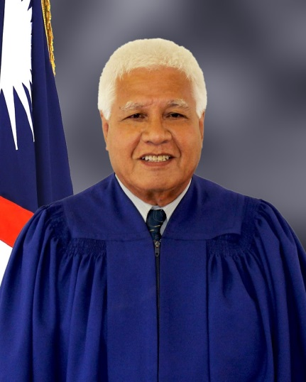
On August 21, 1967, Judge Zackios started on his career path working as an Assistant Clerk of the Courts for the Trust Territory of the Pacific Islands Judiciary (Marshall Islands District). As part of the process towards self-government, the Marshall Islands commenced constitutional government on May 1, 1979. The Judicial Branch of the Government of the Republic of the Marshall Islands was certified per Secretarial Order 3039 on March 3, 1982 where Milton assumed the role of Chief Clerk of the Courts, Republic of the Marshall Islands Judiciary. He served in this capacity for 21 years until his appointment by the Judicial Service Commission on March 31, 2003 to serve as a third Associate Judge for the District Court. In April of 2005 he was appointed to serve as the Presiding Judge of the District Court. Judge Zackios would serve as Presiding Judge until reaching the mandatory retirement age on December 25, 2018.

Kommol tata Presiding Judge Zackios for your 51 years of service!

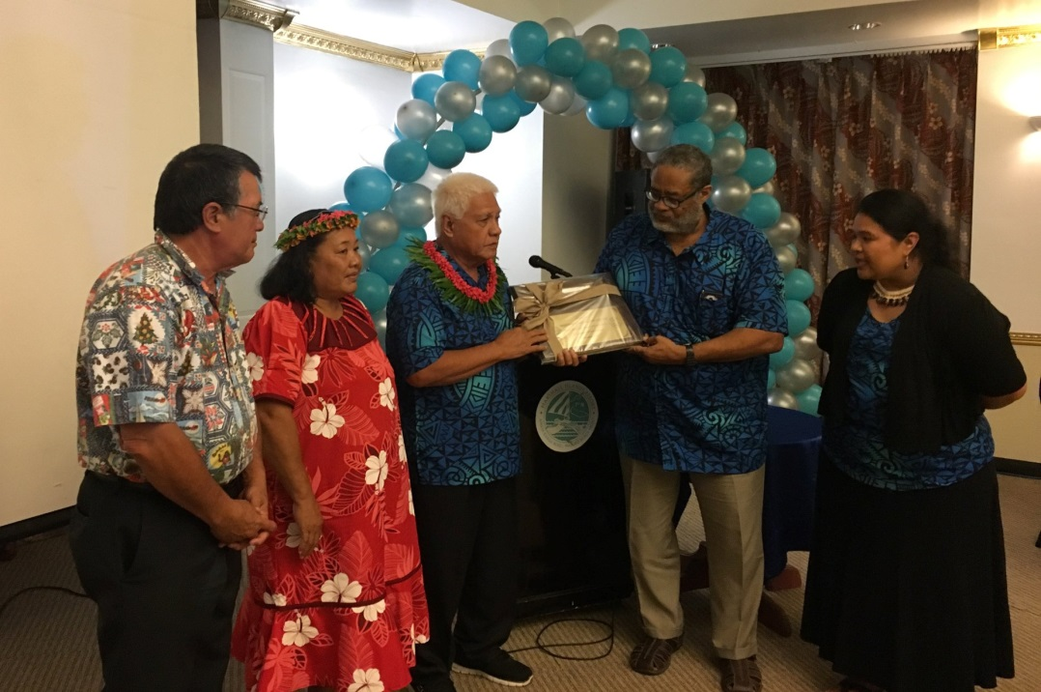

2018 REPORT
OF THE JUDICIARY OF THE
REPUBLIC OF THE MARSHALL ISLANDS

I. INTRODUCTION

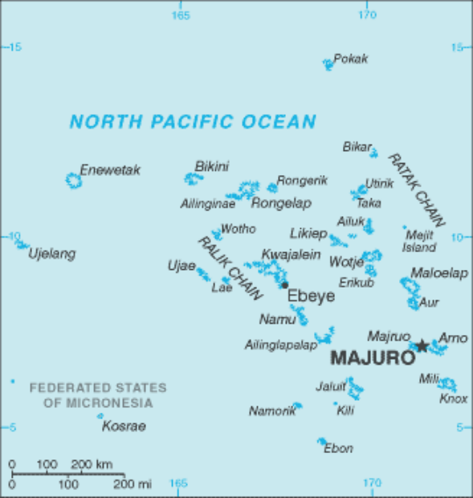
The Republic of the Marshall Islands consists of two nearly parallel island chains of 29 atolls and five separate islands—1,225 islands in all—located about half way between Hawaii and Australia. The Republic’s land mass totals 70 square miles scattered over 750,000 square miles of the Pacific Ocean. As of January 1, 2018, the estimated population of the Marshall Islands was approximately 55,036. However, estimates vary greatly.

The Republic of the Marshall Islands is a young nation. After more than three decades of United States administration under the United Nations Trust Territory of the Pacific Islands (TTPI), the Marshall Islands commenced constitutional government on May 1, 1979, as part of a process toward self-government. Seven and half years later, on October 21, 1986, the Marshall Islands formally regained independence through an agreement with the United States, the Compact of Free Association. The Republic is now self-governing under its own constitution.

Under the Constitution, the Marshall Islands has a Westminster-style government with a 33-member parliament called the Nitijela. At least every four years, after national elections, the Nitijela elects from its members a president, who in turn selects eight to ten other Nitijela members for his or her cabinet. The Constitution vests legislative authority in the Nitijela (the parliament) and the Imon Iroij (House of Chiefs), executive authority in the Cabinet, and judicial authority in the judiciary (“RMI Judiciary”).

Article VI of the Constitution provides for a judiciary “independent of the legislative and executive powers.” The RMI Judiciary comprises five levels of courts, as well as a Judicial Service Commission and court staff. The courts include the Supreme Court, the High Court, the Traditional Rights Court, the District Court, and the Community Courts. The RMI Judiciary officially commenced operation on March 3, 1982, assuming judicial functions in the Marshall Islands, which had been discharged by the High Court of the TTPI. An organizational chart of the RMI Judiciary is attached as Appendix 1, and a listing of RMI Judiciary personnel at the end of calendar year 2018 is attached as Appendix 2.

In the sections that follow, this report summarizes the RMI Judiciary’s operations and accomplishments in calendar year 2018, as well as its challenges, including the need for financial support. These sections include the following:

- Significant Events and Accomplishments;

- The Courts: Efficiency, Quality, and Accessibility;

- The Judicial Service Commission: Judicial Appointments;

- Accountability: Codes of Conduct and Complaints;

- Facilities, Technology, and Library; and

- Annual Budget and Audit Report.

II. SIGNIFICANT EVENTS AND ACCOMPLISHMENTS

The dedication and hard work of the judges and staff that serve the RMI Judiciary made 2018 a successful year. The most significant events and accomplishments include the following:

- Increased demand on judge-time and the Judiciary's resources arising from cases involving corporations, maritime matters, and the enforcement of foreign judgments;

- Plans for a new Ebeye Courthouse;

- Completion of a police substation next to the Majuro Courthouse; and

- Conducting our fourth biennial User Satisfaction Survey

A. Increase in Corporate, Maritime, and Enforcement of Foreign Judgments Cases

In 2018, the RMI cases involving corporations, maritime, and enforcement of foreign judgments continue to demand much more judicial time and attention than other cases. Even a few cases can require weeks of judge-time in the High Court and the Supreme Court to resolve. In June 2018, the only cases heard on appeal by the Supreme Court were four non-resident corporate, enforcement of judgments, and maritime cases.

As the Marshall Islands Ship Registry and the Marshall Islands Trust Company continue to grow, more non-resident disputes are being heard by the High Court and the Supreme Court. This is particularly true when there is a down turn in the global economy. Because of this increased workload, the RMI Judiciary requests funding for a third High Court justice. The third justice also is needed to ensure that the needs of the people of the Marshall Islands are met, including in conflict-cases and on Kwajalein and the outer islands. The additional personnel cost for a third High Court judge would be about $120,000. The RMI Judiciary seeks a budget increase to cover this cost and related expenses.

B. Ebeye Courthouse

In 2017, the RMI Judiciary completed detailed plans and drawings for a new courthouse on Ebeye. The new courthouse would include office space for a prosecutor and defense counsel, as well as a ground floor court room, judges’ chambers, and clerk’s office. The cost to construct and furnish the new courthouse would be approximately $800,000. The RMI Judiciary was not able to obtain funding for the project in the FY 2018 budget but will continue to seek funding for this vital project.

C. Police Substation for Majuro Courthouse
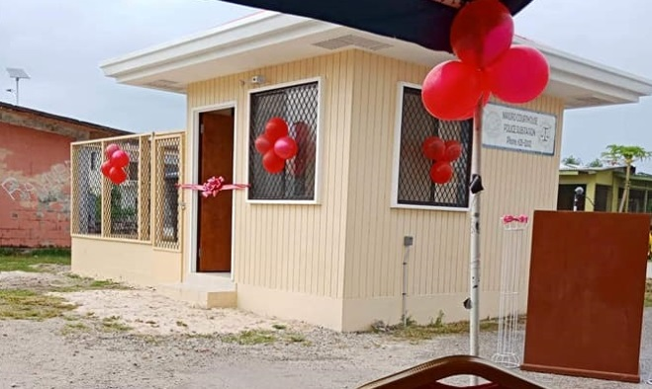
In late 2017 the RMI Judiciary commenced construction of a National Police Substation next to the Majuro Courthouse. The project was completed in early 2018. The station is manned by officers from the National Police Department. The aim of the new police substation is to address nighttime vandalism and assaults in the area.

D. User Satisfaction Survey

Over two weeks from November 5 to 16, 2019, the Judiciary conducted a user survey at both the Majuro Courthouse and the Ebeye Courthouse. The Majuro Courthouse had 78 survey participants, and the Ebeye Courthouse had 12. The survey results are attached as Appendix 4. We were pleased to learn that, as in past years, court users rate the judiciary high on both access and fairness. For example, in response to the questionnaire prompt “Court staff paid attention to my needs” 98.70% of Majuro respondents said yes and all Ebeye respondents (100%) said yes. In response to the questionnaire prompt “I was able to get my court business done in a reasonable amount of time,” 94.74% of the Majuro respondents and 91.67% of the Ebeye respondents said yes. Generally, court users gave the Judiciary high marks in timeliness, safety and security, responsiveness to information requests, respect, clear signs, fair and reasonable outcomes, equality of treatment, and clarity in delivery of services. However, in both Majuro and Ebeye, users clearly did not know it is possible to seek a waiver of a court fee in civil or family cases if a person is financially disadvantaged and did not know how to make a complaint or provide feedback to the Judiciary in relation to their treatment by either a judicial officer or court staff. This is a matter the Judiciary will have to address through educating the public. As part of its outreach efforts, the Judiciary has and will continue to provide for public and private school students “learning tours” of the courts, newspaper advertisements on the Judiciary’s services. After the November 2018 general election, the judges may need to travel to the outer islands to swear in the local government council members. The Judiciary plans to meet with and to conduct presentations to the newly elected government members and outer island residents, educating them about the Judiciary, its role, and its services.

III. THE COURTS: EFFICIENCY, QUALITY, AND ACCESSIBILITY

The goals of the RMI Judiciary include to be efficient, to produce quality decisions, and to be accessible.

- The RMI Judiciary’s efficiency can be measured by annual clearance rates, time standards, the age of cleared cases, and the age of pending cases.

- The quality of decisions can be measured by appeals and cases overturned on appeal.

- Accessibility can be measured by fee waivers, lower fees for vulnerable litigants, cases heard on circuit, free legal counsel, the availability of forms, the accessibility of courthouses, and access for women and those with disabilities.

To these ends, the 2018 Annual Report reviews all five levels of the RMI Judiciary—the Supreme Court, the High Court, the Traditional Rights Court, the District Court, and the Community Courts. The review includes the courts’ jurisdictions, staffing, and case statistics, as well as continuing professional development for judges and staff.

A. Supreme Court

The Supreme Court, the court of last resort, is a superior court of record having appellate jurisdiction with final authority to adjudicate all cases and controversies properly brought before it. An appeal lies to the Supreme Court:

(i) as of right from a final decision of the High Court in the exercise of its original jurisdiction;

(ii) as of right from a final decision of the High Court in the exercise of its appellate jurisdiction, but only if the case involves a substantial question of law as to the interpretation or effect of the Constitution; and

(iii) at the discretion of the Supreme Court from any final decision of any court.

Also, the High Court may remove to the Supreme Court questions arising as to the interpretation or effect of the Constitution.

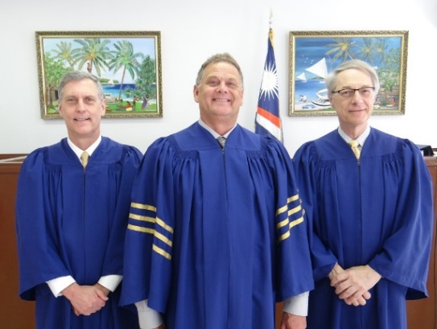
The Supreme Court consists of three justices: a chief justice and two associate justices. To date, all Supreme Court judges have been law-trained attorneys and most have been experienced judges. The current chief justice, Daniel N. Cadra, is a United States citizen appointed to a second 10-year term effective September 2013. Generally, associate justices have been acting judges from other jurisdictions — the United States Ninth Circuit Court of Appeals, the United States Federal District Court in Hawaii, the Republic of Palau, the Commonwealth of the Northern Mariana Islands, and Canada. In 2018, the acting associate justices were two United States Federal Court judges: District Court Judge Michael Seabright from the Hawaii District and District Court Judge Richard Seeborg from Northern California. The Chief Clerk of the Courts, Ingrid K. Kabua, serves as the clerk of the Supreme Court.

The Supreme Court’s 2018 case and workload are summarized below, including annual clearance rates, annual average age of cleared cases, and annual average age of pending cases.

Like the High Court, the Supreme Court has been affected by the increasing number of complex cases involving corporate, maritime, and enforcement of foreign judgment cases. At the beginning of 2018, there were six matters pending before the Supreme Court, and in 2018, another 15 matters, a record number, were filed. In 2018, eight cases were disposed: the Supreme Court affirmed four High Court final decisions and dismissed and denied appeals against two interim High Court decisions. Two appeals were by Supreme Court rule ineffective as filed, having been filed while motions to reconsider were still pending before the High Court. By the end of 2018, 13 cases remained.

The Supreme Court’s goal is to maintain an average annual clearance rate of 100% over five years. As the table below shows, the Supreme Court's five-year average clearance rate is over 100% at 100.67%. The Supreme Court achieved an annual clearance rate of 100% in two of the past five years. In 2018, with 15 cases filed and eight cases cleared, the annual clearance rate was 53.33% (8/15). However, The RMI Judiciary anticipates that the Supreme Court’s average annual clearance rate will continue to fluctuate around 100%.

Annual Clearance Rates for Supreme Court Cases 2014-2018
 | 2014 | 2015 | 2016 | 2017 | 2018 | Avg.
Cases Filed | 4 | 4 | 3 | 6 | 15 | 6.4
Cases Cleared | 6 | 6 | 2 | 5 | 8 | 5.4
Clearance Rate | 150.00% | 150.00% | 66.67% | 83.33% | 53.33% | 100.67%
Annual Goal | 100.00% | 100.00% | 100.00% | 100.00% | 100.00% | 100.00%

In addition to the annual clearance rate figure, the RMI Judiciary tracks the average age of cleared Supreme Court cases. The average age of the eight cases cleared in 2018 was 168.88 days. The five-year trend for the average age of cleared Supreme Court cases is set forth below in the table and chart. The high age of cleared cases in 2014 through 2016 is the result of efforts to clear out the backlog of old and abandoned appeals.
Average Age of Cleared Supreme Court Cases 2014-2018
 | 2014 | 2015 | 2016 | 2017 | 2018
Cases Cleared | 6 | 6 | 2 | 5 | 8
Avg. Age of Cleared Cases | 895.00 | 687.00 | 828.50 | 387.20 | 168.88

In addition to both the clearance rate and average age of cleared cases, to track the Supreme Court’s efficiency, the RMI Judiciary calculates the average age of pending cases. The average age of the 13 cases pending at the end of 2018 was 248.46 days. The five-year trend for the average age of pending Supreme Court cases is set forth below in the table and chart. The reduced age of pending cases, from 486.00 days in 2014 to 216.50 days in 2017, reflects the Supreme Court’s continuing efforts to resolve pending cases quickly.

Average Age of Pending Supreme Court Cases 2014-2018
 | 2014 | 2015 | 2016 | 2017 | 2018
Pending Cases | 6 | 4 | 5 | 6 | 13
Average Age of Pending Cases | 486.00 | 379.25 | 288.60 | 216.50 | 248.46

Beyond being efficient, the RMI Judiciary seeks to be accessible. With respect to the Supreme Court’s accessibility, the RMI Judiciary has received no complaints.

- In none of the cases pending in 2018 did the parties seek a fee waiver or legal aid. The filing fee for appeals is only $50, and the availability of fee waivers was widely publicized.

- In 2018, the Supreme Court tracked the gender of appellees and appellants. Most of the appellants and appellees were males and business entities. Four were women. The gender disaggregation does not reveal any particular pattern or trend, other than to confirm that women have equal access to the courts.

- In 2018, the Supreme Court tracked the disability status of litigants. In two appeals the litigants, elderly women, were disabled. However, no hearings were held in the cases.

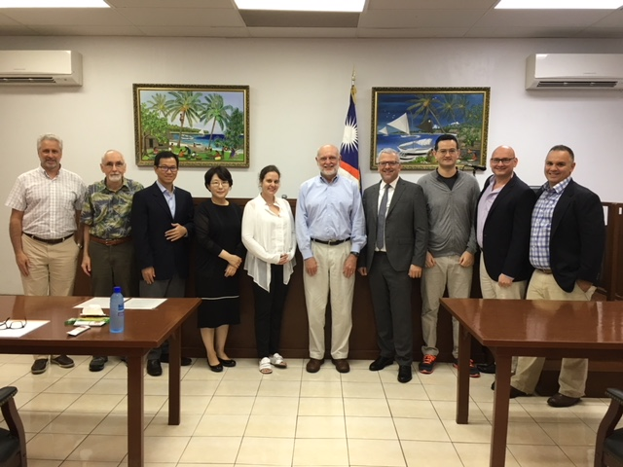
- All the Supreme Court’s decisions can be found on the RMI Judiciary’s website, http://rmicourts.org/, under the heading Court Decisions and Digests.

Aside from the Supreme Court’s regular docket, in 2018, Supreme Court Chief Justice Cadra, together with High Court Chief Justice Carl B. Ingram, admitted nine attorneys to the practice of law in the Republic: one Marshallese working for the Office of the Legislative Counsel; and eight private attorneys. The Marshall Islands annual bar examination was administered in July to 10 non-resident attorneys.

B. High Court
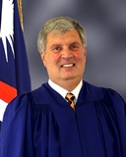
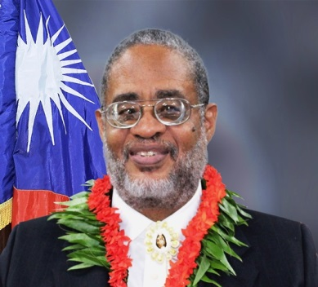
The High Court is the highest court at the trial level. It is a superior court of record having general jurisdiction over controversies of law and fact in the Marshall Islands. The High Court has original jurisdiction over all cases properly filed with it, appellate jurisdiction over cases originally filed in subordinate courts, and, unless otherwise provided by law, jurisdiction to review the legality of any final decision of a government agency.

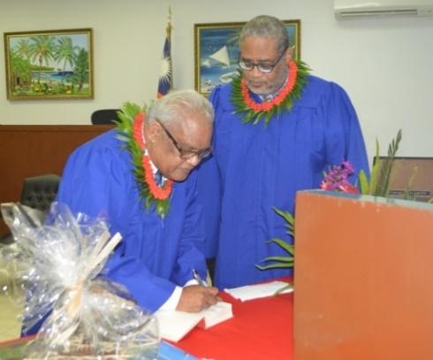
The High Court currently consists of a chief justice and one associate justice in 2018: Chief Justice Carl B. Ingram; through October, Associate Justice Colin R. Winchester; and in November and December Associate Justice Witten T. Philippo. All are law-trained attorneys, as have been all prior High Court judges, and attend at least one professional development seminar or workshop each year. Chief Justice Ingram was appointed to a second ten-year term commencing in October 2013. Associate Justice Winchester was appointed to a two-year term commencing in November 2016. Associate Justice Philippo, as a citizen of the Republic was appointed until age 72 (January 31, 2030). Although Chief Justice Ingram is a United States citizen, he has lived and worked in the Marshall Islands since 1979.

In addition to the two justices, the High Court is served by a chief clerk of the courts, a deputy chief clerk of the courts, and two assistant clerks. The High Court’s 2018 case statistics for civil cases, probate cases, criminal cases, juvenile cases, and caseloads are set forth below.

1. Civil Cases (other than Probate Cases)

The High Court’s 2018 statistics for civil cases (other than probate cases) cover the following:

- the number and nature of cases filed;

- the annual clearance rate and the five-year trend;

- the percentage of cleared cases cleared within 120 days and within 24 months in 2018;

- the average age of cleared cases at the end of the year and the five-year trend;

- the average age of pending cases at the end of the year and the five-year trend;

- the percentage of cleared cases appealed and the percentage of cases overturned on appeal; and

- affordability and accessibility in terms of fee waivers, low fees for vulnerable parties, cases heard on circuit, legal aid, forms, and access for women and those with disabilities.

- Number and Nature of Cases Filed

In 2018, plaintiffs and petitioners filed 351 new civil cases (other than probate cases) in the High Court: 324 in Majuro and 27 in Ebeye. This is 14 more cases than were filed in 2017, and 71 more than in 2016.

The 324 civil cases filed in Majuro in 2018 breakdown as follows:

- Almost 77.78%, 252, involved family and personal status matters (including 110 customary adoptions, 60 guardianships, 40 citizenship cases, 13 divorce/child custody and support cases, 12 domestic violence cases seeking protection orders, 10 legal adoptions, six name-change cases, one civil confinement case (involving a man suffering from a mental disorder and TB), and no removal/deportation cases);

- 48 commercial cases (42 collection, no corporate cases, four contracts, and two enforcement of foreign judgment cases);

- 14 land cases (13 land rights cases and one land rights and building case);

- 1 admiralty/maritime cases; and

- 9 other cases (four tort cases, one mandamus case, one declaratory relief case, one injunctive relieve case, and one wrongful death case).

Of the 324 civil cases filed in Majuro in 2018, 264 were cleared in 2018, leaving 60 pending at the end of the year. The three largest categories of pending cases were as follows: 22 collection, 12 land or lease cases; 11 citizenship cases.

Of the 27 civil cases filed in Ebeye in 2018, 15 were customary adoptions, four were divorce cases, three were child support cases, three were collection cases, one was a domestic violence, and one was a guardianship case. Of the 27 cases filed, 19 were cleared in 2018, leaving eight pending at the end of the year: three child support cases, three divorce cases, and one collection cases.

The High Court tracks the gender of plaintiffs and defendants. However, other than confirming that almost all child support cases and protection order cases are filed by women against men, the case numbers disaggregated by gender do not reveal any particular pattern or trend.

The High Court also tracks the disability status of litigants. As noted above, only one man with mental disorders and TB was the subject of an action by the Government for civil confinement. The man is represented by the Office of the Public Defender. The most common disability is difficulty walking. Less than 5 litigants, witnesses, and attorneys fell into this category in 2018. When litigants, attorneys, or witnesses cannot easily climb stairs, their cases are heard in a ground floor courtroom, and land rights cases, which involve older litigants and witnesses, are as a rule heard in a ground floor courtroom. Also, witness depositions are used, particularly if the witness is home or hospital bound. Except as noted, disaggregation by disability status does not reveal any particular pattern.

Based upon this civil caseload, the High Court measures its efficiency in terms of the annual clearance rates, time standards, the age of cleared cases, and the age of pending cases.

- Annual Clearance Rate and the Five-Year Trend

The High Court’s clearance goal is to achieve an annual clearance rate of 100%, or better. In 2018, the High Court just met the goal. The clearance rate for civil cases was only 100%: 351 cases were cleared and 351 were filed.

As the table and chart below show, the High Court has met its goal in four of the past five years. The drop of the clearance rate from 143.06% in 2014, to 100.00% in 2018 is the result of the Court’s successful backlog reduction policy. In the near term, the High Court expects its annual clearance rate to fluctuate around 100%.

Annual Clearances Rates for High Court Cases Cleared 2014 to 2018
 | 2014 | 2015 | 2016 | 2017 | 2018 | Avg.
Cases Filed | 281 | 258 | 280 | 337 | 351 | 301.40
Cases Cleared | 402 | 261 | 281 | 314 | 351 | 321.80
Clearance Rate | 143.06% | 101.16% | 100.71% | 93.46% | 100.00% | 106.77%
Annual Goal: 100% | 100.00% | 100.00% | 100.00% | 100.00% | 100.00% | 100.00%

c. Time Standard: Percentage of Cleared Cases Cleared in 120 Days and in 24 Months

In 2018, the High Court sought not only to meet its clearance goal but also to meet its time standard goal to clear 70% of its resolved civil cases within 120 days and 90% within 24 months. The High Court met its time standards for general civil cases. The High Court cleared 84.90% (298/351) of cleared civil cases within 120 days and 98.29% (345/351) within 24 months. As shown below, successfully meeting time standards has led to a reduction in the average age of cleared cases.

d. Average Age of Cleared Cases at the End of the Year and the Five-Year Trend

In 2018, the average age of cleared cases was 114.70 days. The table and chart below show that, over the past five years, the average age of cleared cases has come down and flattened out. This is due to the Court’s backlog reduction policy.

Average Age of High Court Civil Cases Cleared 2014-2018
 | 2014 | 2015 | 2016 | 2017 | 2018
Number of Cleared Cases | 402 | 261 | 282 | 314 | 351
Average Age in Days | 595.35 | 224.13 | 164.88 | 140.14 | 114.70
Average Age of Middle 75% | 400.18 | 66.79 | 45.93 | 49.38 | 47.03
Median Age in Days | 35.00 | 11.00 | 7.00 | 8.00 | 8.00

Just as the average age of cleared cases and of pending cases has gone down in 2018.

e. Average Age of Pending Cases at the End of the Year and the Five-Year Trend

In 2018, the number of pending cases went up slightly from 121 in 2017 to 123 in 2018. Also, the age of pending increased slightly from 1,027.31 in 2017 to 1,058.02 days in 2018. This is the result of the High Court’s successful backlog reduction project. Older cases are being cleared, and the High Court has reached a point where it can resolve about as many cases as they come in. As the table and chart below show, since 2014 the number of pending cases has remained flat. Of the 123 cases pending at the end of 2018, a little less than 50% were land cases and 25% were complex corporate and maritime cases. The Traditional Rights Court and the High Court are trying hard to resolve the land cases.

Average Age of Pending High Court Cases 2014-2018
 | 2014 | 2015 | 2016 | 2017 | 2018
Number of Pending Cases | 103 | 99 | 98 | 121 | 123
Average Age in Days | 1,569.88 | 1,368.81 | 1,303.62 | 1,027.31 | 1,058.02
Average Age of Middle 75% | 1,376.09 | 1,182.38 | 1,086.99 | 798.15 | 812.78
Median Age in Days | 1017 | 633 | 544 | 300 | 270
% Reduction in Pndg Cases | -53.81% | -3.88% | -0.01 | 23.47% | 1.65%

f. Appeals

In addition to measuring efficiency, it is important to review the quality of judgments. Courts can measure the quality of their judgments in two ways: the percentage of cleared cases appealed and the percentage of cases overturned on appeal.

In 2018, the number and percentage of High Court civil cases appealed increased significantly. There were 14 cases appealed to the Supreme Court (five land cases (two of which were ineffective as filed before the trial case was final); four corporate cases; two election cases; one civil fraud cases; one criminal case; and one juvenile case). That is, 14 appeals versus 351 cases cleared in the High Court, or 3.99%. Below is a table and chart showing the number of cleared cases appealed versus cleared cases not appealed over the past five years.

Cleared High Court Civil Cases Not Appealed v. Appealed 2014-2018
 | 2014 | 2015 | 2016 | 2017 | 2018 | Avg.
Cases Cleared | 402 | 260 | 281 | 314 | 351 | 321.60
Cases Appealed | 4 | 4 | 2 | 6 | 14 | 6.00
Cases Not Appealed | 398 | 256 | 279 | 308 | 337 | 315.60

In 2018, no High Court civil cases from 2018, or from previous years, were overturned on appeal. The percentage of cases overturned on appeal was 0%.

g. Affordability and Accessibility: Fee Waivers; Cases Heard on Circuit; Legal Aid; Forms; and Access for Women and Those with Disabilities

It is not enough that courts be efficient and that the quality of judgments be high. The courts must be affordable and accessible. Affordability and accessibility to justice may be measured in terms of the availability of fee waivers, lower fees for vulnerable parties, the number of cases heard on circuit, the availability of free legal service, and the availability of forms.

- By rule and statute, fee waivers are available upon a showing of need. In 2018, the High Court continued to aggressively published fee waiver rules, however, no one requested a fee waiver in a High Court civil case.

- The filing fee for most types of High Court civil cases remained low: only $25. And in 2016, the filing fee for child custody and support cases (usually filed by single mothers) was reduced from $25 to $5. To off-set the low fees for most users, fees for admiralty cases, enforcement of foreign judgments, non-resident corporate cases, international adoptions, and citizenship cases are substantially higher.

- In 2018, a number of High Court cases were heard on the Ebeye circuit. Of the 351 civil cases filed in 2018, 27 cases (7.69%) were Ebeye circuit cases. Of the 352 civil cases cleared in 2018, 24 cases (6.82%) were Ebeye circuit cases.

- In 2018, the use of free legal services remained high. In 220 of the 351 civil cases filed in 2018 (69.23%), at least one of the parties was represented by the Micronesian Legal Services Corporation or the Office of the Public Defender, both of which provide legal assistance for free. Also, in 2018, approximately 16 potential plaintiffs were assigned a free court-appointed attorney for their claims. For FY 2018, the Nitijela appropriated $15,000 to the RMI Judiciary to pay court-appointed attorneys to represent those who cannot afford an attorney and for conflict reasons cannot use the Micronesian Legal Services Corporation or the Office of the Public Defender. The RMI Judiciary collected another $37,500 in FY 2018 for the court-appointed attorneys from private counsel who wished to opt-out of taking court-appointed cases.

- The RMI Judiciary has long used forms in small claims cases, name-change petitions, and guardianship cases. Since 2013, the RMI Judiciary has posted forms on its website for confirmation of customary adoptions, name-change petitions, fee and cost waivers, domestic-violence temporary protection orders, guardianship petitions, and small claims cases.

2. Probate Cases

Set forth below are the High Court’s 2018 case statistics for probate cases, covering:

- the number of probate cases;

- the annual clearance rate and the five-year trend;

- the percentage of cases cleared within 90 days;

- the average age of cleared cases at the end of the year and the five-year trend;

- the average age of pending case(s) at the end of the year and the five-year trend;

- the percentage of cleared cases appealed and the percentage of cases overturned on appeal; and

- affordability and accessibility in terms of fee waivers, low fees for smaller cases, cases heard on circuit, legal aid, and access for women and those with disabilities.

a. Number of Probate Cases

Only six probate cases were filed in 2018, four less than in 2017. All six cases were filed in Majuro. None were filed in Ebeye.

- Annual Clearance Rate and the Five-Year Trend

In 2018, the High Court cleared five of the six Majuro probate cases filed in 2018, one Majuro case from 2017, and one Ebeye case from 2017, for a clearance rate of 116.67% (6/7). Since the backlog in probate cases has been eliminated, the High Court’s goal for probate cases is to maintain an average annual clearance rate of 100% over five years. As the table and chart below show, the High Court has achieved its goal. The average annual clearance rate over the past five years is 105.28%. Given the relatively low number of probate cases filed each year, the annual clearance rate should fluctuate around 100%.

Annual Clearance Rates for High Court Probate Cases 2014-2018
 | 2014 | 2015 | 2016 | 2017 | 2018 | Avg.
Cases Filed | 8 | 9 | 9 | 9 | 6 | 8.20
Cases Cleared | 7 | 10 | 10 | 9 | 7 | 8.60
Clearance Rate | 87.50% | 111.11% | 111.11% | 100.00% | 116.67% | 105.28%
Clearance Rate Goal | 100% | 100% | 100% | 100% | 100% | 100%

c. Time Standard: Percentage of Cleared Cases Cleared within 90 Days of the Date Filed

In additional to the goal of an average annual clearance rate of 100% over five years, the High Court seeks to clear 90% of cleared probate cases within 90 days. Of the seven probate cases cleared in 2018, the High Court was able to clear only two, 28.57%, within 90 days. Most delays were caused by the petitioners' scheduling requests. The High Court was prepared to move the cases more quickly.

d. Average Age of Cleared Cases at the End of the Year and the Five-Year Trend

The average age of the 7 probate cases cleared in 2018 was 105.57 days. Absent an objection or delays by the petitioner and counsel, most probate cases are cleared within seven to 11 weeks of filing, i.e., within 49 to 77 days. Below is the five-year trend for the average age of cleared probate cases. It shows that after clearing out its backlog in 2014, the High Court is able to clear most probate cases within 90 days.

Average Age of Cleared High Court Probate Cases 2014-2018
 | 2014 | 2015 | 2016 | 2017 | 2018
Cases Cleared | 7 | 10 | 10 | 9 | 7
Avg. Age of Cleared Cases | 1,507.75 | 58.75 | 81.10 | 62.25 | 105.57

e. Average Age of Pending Cases at the End of the Year

At the end of 2018, only one probate matter was pending, a case filed February 8, 2018, by off-island counsel. By the end of the year the case had been pending 326 days. The High Court notified counsel that it would dismiss the case if counsel did not take steps to prosecute the matter. That case was heard and dismissed in January 2019.

f. Appeals

In 2018, no cleared probate cases were appealed, nor were any cases from previous years overturned on appeal. Accordingly, the percentage of cleared probate cases appealed was 0%, and the percentage of appealed probate cases overturned on appeal was 0%. This has been the case for more than the past five years.

g. Affordability and Accessibility: Fee Waivers; Low Fees, Cases Heard on Circuit; and Legal Aid

As noted above, affordability and accessibility to justice can be seen in the availability of fee waivers, low fees for smaller cases, the number of cases heard on circuit, the availability of free legal service, and access for women and persons with disabilities.

- As with other civil cases, fee waivers are available in probate cases. However, in 2018 (as in recent years) no one requested a fee waiver in a probate case. In 2018, the High Court widely published notice of the waivers.

- In 2018, the fees for probate cases remained low. The filing fee for probate cases is $25, $100 for estates over $7,000.

- Of the 6 probate cases filed in 2018, none were Ebeye circuit cases. Of the seven probate cases cleared in 2018, one was an Ebeye circuit case (14.28%).

- In two of the six probate cases filed in 2018 (33.33%), the petitioner was represented by the Micronesian Legal Services Corporation (MLSC). This figure is a little lower than in previous years. In 2018, the four larger probate cases were filed by private counsel. However, MLSC usually moves its cases faster without delays.

- The 2018 probate statistics disaggregated by gender do not reveal a pattern or trend: four of the six petitioners were women and two were men. Usually the petitioner will be the surviving spouse, the eldest surviving child, or, failing either, the most senior surviving child present in Majuro. In 2018, none of the probate petitioners or objectors were a disabled person.

3. Criminal Cases

Set forth below are the High Court’s 2018 case statistics for criminal cases. These statistics cover the following:

- the number and nature of criminal cases;

- the annual clearance rate and the five-year trend;

- the percentage of cleared cases cleared within eighteen months (540 days);

- the average age of cleared cases at the end of the year and the five-year trend;

- the average age of pending cases at the end of the year;

- the percentage of cleared cases appealed and the percentage of cleared cases overturned on appeal; and

- affordability and accessibility (low or no fees, fee waivers, cases heard on circuit, legal aid, and access for women and those with disabilities).

a. Number and Nature of Cases

In 2018, the Office of the Attorney-General filed 26 criminal cases in the High Court: 21 in Majuro and five in Ebeye. This is three less than in 2017.

The 21 criminal cases filed in Majuro in 2018 breakdown (by most serious offense charged) as follows: one manslaughter; one aggravated assault; one official oppression/assault; one burglary; one kidnapping; one assault with a deadly weapon; one possession of stolen explosive material; four forgeries; two escapes; three thefts by unlawful taking; and unlawful entrance; three assaults (one of which included domestic violence); one criminal mischief. In the 21 Majuro cases, three of the defendants were women. None of the defendants were disabled persons.

The five felony cases filed in Ebeye in 2018 breakdown (by most serious offense charged) as follows: one sexual assault in the first degree; two burglaries; one sexual assault in the 3rd degree; and one escape. In the six Ebeye cases, none of the defendants was a woman or a disabled person.

Of the 21 Majuro cases, females were the victims in three cases: one manslaughter (a car accident case that was dismissed); one assault/domestic violence; and one assault/official oppression. In the five Ebeye cases, females were the victims in two cases: sexual assault in the 1st degree; and sexual assault in the 3rd degree. Counseling for victims of domestic violence and sexual violence is available through NGOs, including Youth-to-Youth in Health and Women United Together Marshall Islands.

Other than as noted above, the High Court’s criminal case statistics, disaggregated by gender or disability, do not reveal any pattern or trend.

b. Clearance Rates

The High Court’s clearance goal for criminal cases is an annual clearance rate of 100%, or better. In 2018, the High Court cleared 32 criminal cases from all years, six more than the number of cases filed in 2018, resulting in a 2018 clearance rate of only 123.08% (26/32).

As the chart below shows, the five-year average for the annual clearance rates is above 100%, at 119.27%. In three of the five years the clearance rate was 100% or better.

Annual Clearance Rates for High Court Criminal Cases 2014-2018
 | 2014 | 2015 | 2016 | 2017 | 2018 | Avg.
Cases Filed | 18 | 18 | 18 | 29 | 26 | 21.8
Cases Cleared | 40 | 18 | 15 | 25 | 32 | 26
Clearance Rate | 222.22% | 100.00% | 83.33% | 86.21% | 123.08% | 119.27%
Annual Goal | 100.00% | 100.00% | 100.00% | 100.00% | 100.00% | 100.00%

c. Time Standard: Percentage of Cleared Cases Cleared Within 18 Months

In addition to the annual clearance rate, the High Court seeks to clear 90% of the cleared criminal cases within 18 months (540 days) of the date filed. In 2018, the High Court cleared 31 of the 32 cleared cases (96.88%) within 18 months.

d. Average Age of Cleared Cases

The average age of the 32 High Court criminal cases cleared in 2018 was 178.31 days, down from 202.76 days in 2017. The number of High Court criminal cases cleared in the past five years (2014-2018) and the average duration of cleared cases are as shown below. The high average age of cases cleared in 2014 is the result of clearing very old and abandoned cases. The relatively low average of 220.72 days in 2015, 197.00 days in 2017, and 178.31 days in 2018 is closer to what the High Court believes should be the norm.

Average Age of High Court Criminal Cases Cleared 2014-2018
 | 2014 | 2015 | 2016 | 2017 | 2018
Cases Cleared | 40 | 18 | 15 | 25 | 32
Avg. Age of Cases Cleared | 1,456.15 | 220.72 | 197.00 | 202.76 | 178.31

e. Average Age of Pending Cases

By the end of 2018, 8 criminal cases remained pending: down six from the end of 2017. However, the average age of the pending cases was only 204.88 days: down from 139.00 days at the end of 2017. The High Court has encouraged the prosecutors and defense counsel to resolve older criminal cases, particularly cases older than 365 days. At the end of 2018, none of the remaining 8 cases were more than 333 days old.

f. Appeals

As an indication of the quality of High Court criminal decisions, in 2018 no High Court criminal cases were appealed. Accordingly, the percentage of cases appealed was 0.0%. Also, no cases were overturned on appeal. The percentage of appealed criminal cases overturned on appeal was 0.0%. This is consistent with results from the past five years.

g. Affordability and Accessibility: No Fee or Fee Waivers; Cases Heard on Circuit; and Legal Aid

The RMI Judiciary seeks to ensure its users affordability and accessible criminal justice through the absence of fees and the availability of fee waivers, circuit court sessions, and free legal representation.

That is, the RMI Judiciary does not impose fees or court costs on criminal defendants at the trial level. And on appeal, a defendant may apply for waiver of the filing fee and transcript costs.

More serious felony cases are heard on circuit with a High Court justice and clerk traveling from Majuro to the island where the crime allegedly occurred. Of the 26 criminal cases filed in 2018, five cases (19.23%) were Ebeye circuit cases. Of the 32 criminal cases cleared in 2018, three cases (9.38%) were Ebeye circuit cases.

Finally, criminal defendants have access to free legal counsel. In 2018, as in other years, most criminal defendants were represented by the Office of the Public Defender or the Micronesian Legal Services Corporation. In 2018, the defendants received legal assistance at no cost from the Office of the Public Defender in all but two cases. In one of the two cases, the defendant fled the Republic before being brought before the Court. In the other case, the defendant and his family can afford a private attorney. This high use of free counsel in criminal cases is typical of most years.

4. Juvenile Cases

In 2018, the Office of the Attorney-General did not file any juvenile cases in the High Court, and only one juvenile case was filed in and pending from 2017. Since 2006, when the Republic filed seven juvenile cases in Majuro, the Republic has filed no more than four High Court juvenile cases in a year. Most juvenile cases (underage drinking) are heard by the District Court, not the High Court. In recent years, all juvenile offenders were boys. None of the juveniles has been identified as disabled.

If the number of juvenile cases were to increase, the High Court’s clearance goal would be 100%. That is, in any one year the High Court would try to clear as many cases as were filed. Also, the High Court would seek to clear 80% of juvenile cases within six months of filing.

However, as noted above, in 2018 no juvenile cases were filed and only one was pending from 2017. The 2017 case, a very serious and complex one, was concluded February 2, 2018, after 171 days. That case is now before the Supreme Court on appeal.

As a result of the low number of juvenile cases being filed in the High Court, there is no meaningful average age of cleared or pending cases for 2018 or for a five-year trend report.

As noted above, in 2018, the one juvenile case the High Court decided was appealed. Accordingly, the percentage of juvenile cases appealed is 100%. That case is still pending before the Supreme Court.

To ensure accessibility to justice, the RMI Judiciary does not impose fees or court costs on juvenile offenders at the trial level. On appeal, a juvenile offender may apply for a fee waiver. Also, High Court juvenile cases are heard on circuit and juvenile offenders have access to free legal counsel. Almost all juvenile offenders are represented by the Office of the Public Defender.

5. Caseloads for Judges and Clerks

The total number of all High Court cases filed in 2018 was 383, 6 more than in 2017. For the two High Court Justices, this equates to an average caseload of 191.50 new cases in 2018. These figures are consistent with recent years, although the figures are trending higher:

- for 2018, 191.50 cases per justice;

- for 2017, 188.50 cases per justice;

- for 2016, 153.50 cases per justice;

- for 2015, 143.50 cases per justice; and

- for 2014, 155.50 cases per justice.

Generally, cases are assigned between the two judges on an alternating basis.

For the five clerks that regularly process High Court cases, their 2018 caseload included 76.60 new cases per clerk. As with the justices, the clerks’ caseloads fluctuate from year-to-year within a limited range, although the figures are trending higher:

- for 2018, 76.60 cases per clerk;

- for 2017, 75.40 cases per clerk;

- for 2016, 61.40 cases per clerk;

- for 2015, 57.40 cases per clerk; and

- for 2014, 62.20 cases per clerk.

There is some specialization among the clerks, but all clerks handle most functions.

Average Caseload for High Court Justices and Clerks 2014-2018
 | 2014 | 2015 | 2016 | 2017 | 2018
Cases per Judge | 155.50 | 143.50 | 153.50 | 188.50 | 191.50
Cases per Clerk | 62.20 | 57.40 | 61.40 | 75.40 | 76.60

6. Selected Decisions

Selected High Court decisions can be found on the RMI Judiciary’s website, http://rmicourts.org/, under the heading Court Decisions and Digests. The selected cases are the noteworthy ones; ones that the RMI Judiciary believes should be published for the benefit of the public and practitioners. The High Court will not publish a case unless it satisfies one or more of the following standards: (1) the opinion lays down a new rule of law, or alters, modifies an existing rule, or applies an established rule to a novel fact situation; (2) the opinion involves a legal issue of continuing public interest; (3) the opinion directs attention to the shortcomings of existing common law or inadequacies in statutes; (4) the opinion resolves an apparent conflict of authority. Most High Court decisions are routine in nature and generally are of interest only to the parties. The public can get copies of these decisions upon request to the Clerk of the Courts.

C. Traditional Rights Court

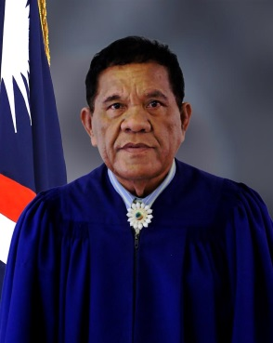
Supporting the High Court at the trial level is the Traditional Rights Court (“TRC”). The TRC is a special-jurisdiction court of record consisting of three or more judges appointed for terms of four to ten years, not to exceed age 72, and selected to include a fair representation of all classes of land rights: Iroijlaplap (high chief); where applicable, Iroijedrik (lower chief); Alap (head of commoner/worker clan); and Dri Jerbal (commoner/worker).

In June 2010, the Cabinet appointed Chief Judge Walter K. Elbon (alap member) and Associate Judge Grace L. Leban (dri jerbal member) for terms of 10 years. In April 2013, the Cabinet appointed Nixon David (iroij member) for a 4-year term, and in March 2017 reappointed Judge David for a second four-year term. All TRC judges are lay judges who receive specialized training.

One of the three TRC judges, Judge Leban, is a woman, the first woman to be appointed as a full-time TRC judge. The RMI Judiciary is committed to increasing the number of female judges. However, at the end of the year only three of the RMI Judiciary's approximately 30 judges were women: one Traditional Rights Court judge; and two Community Court judges.

The jurisdiction of the TRC is limited to questions relating to titles to land rights or other legal interests depending wholly or partly on customary law and traditional practices. The jurisdiction of the TRC may be invoked as of right upon application by a party to a pending High Court proceeding, provided the High Court judge certifies that a substantial question has arisen within the jurisdiction of the TRC.

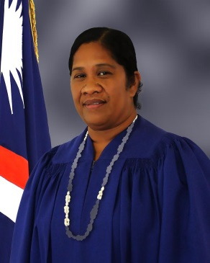
Customary law questions certified by the High Court are decided by the TRC panel and reported back to the High Court. Upon request by the TRC’s presiding judge, a party, or the referring High Court judge, the Chief Justice of the High Court may appoint a High Court or District Court judge to sit with the TRC to make procedural and evidentiary rulings. In such joint-hearing cases, the High Court or District Court judge does not participate with the TRC in deliberations on its opinion, but the High Court or District Court judge may in the presence of the parties or their counsel answer questions of law or procedure posed by the TRC. The TRC’s jurisdiction also includes rendering an opinion on whether compensation for the taking of land rights in eminent domain proceedings is just.

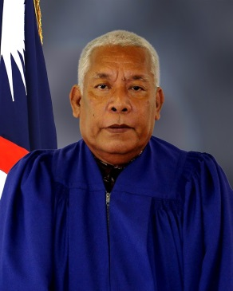
The Constitution states that the High Court is to give decisions of the TRC substantial weight, but TRC decisions are not binding unless the High Court concludes that justice so requires. The Supreme Court has held the High Court is to review and adopt the TRC’s findings unless the findings are clearly erroneous or contrary to law.

In 2018, the TRC issued decisions in nine cases, 7 more than in 2017. As of June 25, 2019, the TRC has issued 3 decisions. Twenty land cases are pending before the TRC and another 6 cases (in the High Court) are pending the outcome of land cases. In the second half of 2019 and the first quarter of 2020, the TRC has set 12 cases for trial.

The TRC’s decisions can be found on the RMI Judiciary’s website, http://rmicourts.org/, under the heading Court Decisions and Digests.

D. District Court

In addition to the TRC, the District Court is below the High Court at the trial level. The District Court is a limited-jurisdiction court of record. It consists of a presiding judge and two associate judges appointed for 10-year terms, not to exceed age 72. In 2018, the three incumbent judges were Presiding Judge Milton Zackios, Associate Judge A. Tarry Paul, and Associate Judge Davidson T. Jajo (Ebeye). Their 10-year terms expire in 2018, 2025, and 2026, respectively.

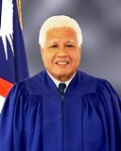
The current District Court judges are lay judges who receive specialized training. The District Court has original jurisdiction concurrent with the High Court

- in civil cases where the amount claimed or the value of the property involved does not exceed $10,000 (excluding matters within the exclusive jurisdiction of the High Court by Constitution or statute, such as land title cases and admiralty and maritime matters) and
- in criminal cases involving offenses for which the maximum penalty does not exceed a fine of $4,000 or imprisonment for a term of less than three years, or both.

The District Court also has appellate jurisdiction to review any decision of a Community Court.

The District Court’s 2018 case statistics and case workload are set forth below.

1. Traffic Cases (Majuro)

The District Court’s 2018 statistics for Majuro traffic cases cover the following:

- the number and nature of cases filed in 2018;

- the annual clearance rates for the most recent five years;

- the average duration of cleared cases for the most recent five years;

- the percentage of cases appealed and the percentage of appealed cases overturned on appeal; and

- affordability and accessibility in terms of fee waivers, cases heard outside of Majuro (the Capital), legal aid, and forms.

a. Number and Nature of Cases Filed

In 2018, the National Police and Majuro Atoll Local Government Police prosecutors filed in the District Court a total of 1,126 traffic cases in Majuro. Of the 1,126 traffic cases, a total of 277 cases involved DUI/Drunken Driving.

Of the 1,126 traffic cases filed in Majuro in 2018, 981 were cleared in 2018, leaving 145 pending at the end of the year. Some cases are delayed because the defendants gave false addresses or have fled the Republic for the United States or have fled Majuro for the outer islands.
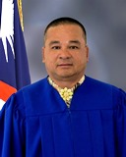
b. Clearance Rates

The District Court’s efficiency can be measured by case clearance rates. The District Court’s 2018 annual clearance rate for traffic cases was 97.16% (finalized/filed). During 2018, the District Court, counsel, and parties closed 981 2018 cases and 113 cases from previous years (2015-2017). And as noted above, the government filed 1,126 new cases in 2018. The District Court’s goal is to maintain an annual clearance rate for traffic cases of 100% or better, for each year.

The District Court each month dismisses without prejudice abandoned cases that have been pending six months or more.

c. Average Duration of Traffic Cases Cleared
The average duration of District Court traffic cases cleared in 2018 was 45 days. A total of 981 2018 cases, 104 2017 cases, 8 2016 cases, and 1 2015 case were cleared in 2018. Excluding cases from earlier years cleared in 2018, the average duration of 2018 traffic cases cleared in 2018 is only 22 days.

For Majuro District Court traffic cases filed in the five years (2014-2018), the average durations of cleared cases in days were as follows:

d. Appeals

In addition to measuring efficiency, it is important to review the quality of judgments. The quality of judgments can be measured in two ways: the percentage of cases appealed and the percentage of appealed cases overturned on appeal.

In 2018, none of the 1,094 District Court traffic cases cleared in 2018 were appealed to the High Court. Similarly, in 2013, 2014, 2015, 2016, and 2017 no traffic cases were appealed.

Furthermore, in 2018, there were no District Court traffic cases or decisions overturned from any year on appeal.

e. Affordability and Accessibility: Fee Waivers; Cases Heard Outside of Majuro; Legal Aid; and Forms

As noted earlier, it is not enough that courts be efficient and that the quality of judgment be high. The courts must be affordable and accessible. Affordability and accessibility to justice may be measured in terms of the availability of fee waivers, the number of cases heard outside of the capital Majuro, the availability of free legal service, and the availability of forms.

(i) Fee Waivers

As there are no filing fees for traffic cases, fee waivers are not applicable.

(ii) Cases Heard on Ebeye

A third District Court judge is stationed in Ebeye to handle District Court matters including traffic cases filed there.

(iii) Free Legal Services

At the District Court level, most traffic offenders are self-represented. Only in more serious cases, such as those involving DUI, do they seek legal assistance and representation by the Micronesian Legal Services Corporation or the Office of the Public Defender, which both provide free legal assistance. Of the 1,126 traffic cases filed in 2018, only 179 defendants (16%) were represented by the Office of the Public Defender, 947 represented themselves (84%), and none were represented by private counsel (0%).

(iv) Forms

Consent judgment forms are available at the Clerk’s Office for traffic offenders who wish to plead guilty and pay a fine. Those who use the form do not have to appear in court.

2. Criminal Cases (Majuro)

The District Court’s 2018 statistics for Majuro criminal cases cover the following:

- the number and nature of cases filed in 2018;

- the annual clearance rates for the most recent five years;

- the average duration of cleared cases in the most recent five years;

- the percentage of cases appealed and the percentage of appealed cases overturned on appeal; and

- accessibility in terms of fee waivers, cases heard outside of Majuro, legal aid, and forms.

a. Number and Nature of Cases Filed

In 2018, the National Police and Majuro Atoll Local Government Police prosecutors filed in the District Court a total of 696 criminal cases in Majuro.

Of the 696 criminal cases, 633 were cleared in 2018, leaving 63 pending at the end of the year. The 63 cases remained pending due to serious nature, to police having difficulty locating defendants who either relocated to the United States, or to the outer islands of the Republic or gave false addresses.

b. Clearance Rates

The District Court’s 2018 annual clearance rate for criminal cases was 99%. During 2018, the District Court, counsel, and parties closed 633 2018 cases, 52 2017 cases, and 2 cases from 2016. As noted above, the government filed 696 new cases in 2018. The District Court’s goal is to maintain an annual clearance rate for criminal cases of 100% or better, for each year.

c. Average Duration of Cleared Criminal Cases

In addition to annual clearance rates, the efficiency of a case management system can be measured by the age of cleared cases. The average duration of District Court criminal cases cleared in 2018 was 33 days. Excluding the 52 2017 cases 2 2016 cases cleared in 2018, the average duration of 2018 criminal cases cleared in 2018 is only 16 days.

d. Appeals

In addition to measuring efficiency, it is important to review the quality of judgments. The quality of judgments can be measured in two ways: the percentage of cases appealed and the percentage of appealed cases overturned on appeal.

In 2018, none of the District Court criminal cases cleared in 2018 were appealed to the High Court. Similarly, in 2013, 2014, 2015, 2016, and 2017 no criminal cases were appealed. Also in 2018, there were no District Court criminal cases or decisions from any years overturned.

e. Affordability and Accessibility: Fee Waivers; Cases Heard Outside of Majuro; Legal Aid; and Forms

The courts must be affordable and accessible. Affordability and accessibility to justice may be measured in terms of the availability of fee waivers, the number of cases heard outside of the capital Majuro, the availability of free legal service, and the availability of forms.

(i) Fee Waivers

As there are no filing fees for criminal cases, fee waivers are not applicable.

(ii) Cases Heard on Ebeye

A third District Court judge is stationed in Ebeye to handle District Court matters including criminal cases filed there.

(iii) Free Legal Services

At the District Court level, most defendants are self-represented. Only in more serious cases, such as those involving selling alcohol to minors and assault and battery, do defendants seek legal assistance and representation by the Micronesian Legal Services Corporation or the Office of the Public Defender, which both provide free legal assistance. Of the 696 criminal cases filed in 2018, 12 defendants (2%) were represented by the Office of the Public Defender, 684 represented themselves (98%), and none were represented by private counsel (0%).

(iv) Forms

Consent judgment forms are available at the Clerk’s Office for defendants who wish to plead guilty and pay a fine. Those who use the form do not have to appear in court.

3. Juvenile Cases (Majuro)

The District Court’s 2018 statistics for juvenile cases cover the following:

- the number and nature of cases filed in 2018;

- the annual clearance rates for the most recent five years;

- the average duration of cleared cases;

- the percentage of cases appealed and the percentage of cases overturned on appeal; and

- accessibility in terms of fee waivers, cases heard outside of Majuro, legal aid, and forms.

a. Number and Nature of Cases Filed

In 2018, the National Police and Majuro Atoll Local Government Police prosecutors filed in the District Court a total of 111 juvenile cases in Majuro. 47 cases involved curfew violations, 48 involved underage drinking and alcohol related charges, 11 cases involved traffic & DUI related charges, and 5 involved other cases.

Of the 111 juvenile cases filed in Majuro in 2018, 84 were cleared in 2018, leaving 27 pending at the end of the year. As of June 25, 2019, 18 cases have been cleared. Nine cases remain pending due to difficulty in bringing to court both the juvenile and parent(s).

b. Clearance Rates

The District Court’s efficiency in handling juvenile cases can be measured by case clearance rates. The District Court’s 2018 annual clearance rate for juvenile cases was 114%. During 2018, the District Court, counsel, and parties closed 84 cases from 2018, 35 cases from 2017, and 7 2016 cases. And as noted below, 111 new cases were filed in 2018. The District Court’s goal is to maintain an annual clearance rate for juvenile cases of 100% or better, for each year. As a result of its efforts to process cases without undue delay, the District Court was able to gradually increase its clearance rate as shown below.

The District Court each month dismisses without prejudice abandoned cases that have been pending six months or more.

c. Average Duration of Cleared Juvenile Cases

In addition to annual clearance rates, the efficiency of a case management system can be measured by the age of cleared cases. The average duration of District Court juvenile cases cleared in 2018 was 188 days. Excluding the 35 2017 cases and 7 2016 cases cleared in 2018, the average duration of 2018 juvenile cases cleared in 2018 is 118 days. This high figure is due to a large number of juvenile cases cleared in 2018 being dismissed after 6 months or more due to the failure to prosecute.

d. Appeals

The quality of judgments can be measured in two ways: the percentage of cases appealed and the percentage of appealed cases overturned on appeal.

In 2018, none of the 126 District Court juvenile cases cleared in 2018 were appealed to the High Court. Similarly, in 2013, 2014, 2015, 2016, and 2017 no juvenile cases were appealed.

Furthermore, in 2018, there were no District Court juvenile cases or decisions from earlier years overturned on appeal.

e. Affordability and Accessibility: Fee Waivers; Cases Heard Outside of Majuro; Legal Aid; and Forms

The courts must be affordable and accessible. Affordability and accessibility to justice may be measured in terms of the availability of fee waivers, the number of cases heard outside of the capital Majuro, the availability of free legal service, and the availability of forms.

(i) Fee Waivers

As there are no filing fees for juvenile cases, fee waivers are not applicable.

(ii) Cases Heard on Ebeye

A third District Court judge is stationed in Ebeye to handle District Court matters including juvenile cases filed there.

(iii) Free Legal Services

At the District Court level, most juvenile offenders are self-represented. Only in more serious cases do they seek legal assistance and representation by the Micronesian Legal Services Corporation or the Office of the Public Defender, which both provide free legal assistance. Of the 111 juvenile cases filed in 2018, none were represented by private counsel (0%), 111 represented themselves (100%), and none were represented by the Office of the Public Defender (0%). Similarly in previous years, the number of juvenile offenders represented by the Office of the Public Defender or by private counsel has been very low. In 2017, only one juvenile offender was represented by private counsel and none were represented by the Office of the Public Defender.

(iv) Forms

Although consent judgment forms are available at the Clerk’s Office for offenders who wish to plead guilty and pay a fine, these forms are not applicable for juvenile matters as juvenile cases are treated differently. It is a requirement that all juvenile offenders must attend Court with the presence of a parent and counsel.

4. Small Claims Cases (Majuro)

The District Court’s 2018 statistics for Majuro small claims cases cover the following:

- the number and nature of cases filed in 2018;

- the annual clearance rates for the most recent five years;

- the average duration of cleared cases;

- the percentage of cases appealed and the percentage of cases overturned on appeal; and

- affordability and accessibility in terms of fee waivers, cases heard outside of Majuro, legal aid, and forms.

- Number of Cases Filed

In 2018, a total of 145 small claims cases were filed in Majuro.

Of the 145 small claims cases filed in Majuro in 2018, 106 were cleared in 2018, leaving 39 pending at the end of the year. Cases that remained pending at the end of the year involved defendants who either reside in the outer islands, moved to the United States, or cannot be located.

b. Clearance Rates

The District Court’s 2018 annual clearance rate for small claims cases was 88%. During 2018, the District Court, counsel, and parties closed 106 2018 cases and 14 cases from previous years (2016-2017). And as noted in the chart below, 145 new cases were filed in 2018. The District Court’s goal is to maintain an annual clearance rate for small claims cases of 100% or better, for each year.

c. Average Duration of Cleared Small Claims Cases

In addition to annual clearance rates, the efficiency of a case management system can be measured by the age of cleared cases.

The average duration of District Court small claims cases cleared in 2018 was 55 days. A total of 106 2018 cases, 11 2017 cases, and 3 2016 cases were cleared in 2018. Excluding cases from earlier years cleared in 2018, the average duration of 2018 small claims cases cleared in 2018 is only 31 days.

For Majuro District Court small claims cases cleared in the past five years (2014-2018), the average duration of cleared cases in days were as follows:

d. Appeals

In addition to measuring efficiency, it is important to review the quality of judgments. The quality of judgments can be measured in two ways: the percentage of cases appealed and the percentage of appealed cases overturned on appeal.

In 2018, none of the 120 District Court small claims cases cleared in 2018 were appealed to the High Court. Similarly, in 2013, 2014, 2015, 2016, and 2017 no small claims cases were appealed.

Furthermore, in 2018, there was no District Court small claims cases or decisions from any years overturned on appeal.

e. Affordability and Accessibility: Fee Waivers; Cases Heard Outside of Majuro; Legal Aid; and Forms

It is not enough that courts be efficient and that the quality of judgment be high. The courts must be affordable and accessible. Affordability and accessibility to justice may be measured in terms of the availability of fee waivers, the number of cases heard outside of the capital Majuro, the availability of free legal service, and the availability of forms.

(i) Fee Waivers

Although, by rule and statute, fee waivers are available upon a showing of need, plaintiffs did not request a fee waiver in any of the 2018 District Court small claims cases. The filing fee for small claims cases remains low at only $5 dollars.

(ii) Cases Heard on Ebeye

A third District Court judge is stationed in Ebeye to handle District Court matters including small claims cases filed there.

(iii) Free Legal Services

At the District Court level, most plaintiffs and defendants in small claims cases are self-represented. Only in a few cases do defendants seek legal assistance and representation by the Micronesian Legal Services Corporation or the Office of the Public Defender, which both provide free legal assistance. Of the 145 small claims cases filed in 2018, one defendant was represented by private counsel (1%) and only 7 of the defendants (5%) were represented by the Micronesian Legal Services Corporation or the Public Defender. All others appeared pro se.

(iv) Forms

Small claims forms are available on the court’s website (www.rmicourts.org) or at the Clerk’s Office.

In summary, a total of 2,078 cases were filed in the Majuro District Court: 1,126 traffic cases; 696 criminal and local government ordinance cases; 111 juvenile cases; 145 small claims cases; and no other civil cases.

5. Caseload for Judges and Clerks (Majuro)

In 2018, the average number of new cases heard by the two District Court judges in Majuro was 1,039 cases, and the average number of new cases per court clerk was the same.

6. Ebeye

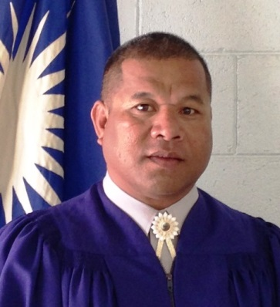
In 2018 on Ebeye, 537 cases were filed in the District Court:
- 96 traffic cases (78 cleared and 18 pending);
- 9 criminal cases (8 cleared and 1 pending);
- 238 local government ordinance cases (197 cleared and 41 pending;
- 179 juvenile cases (179 cleared and 0 pending); and
- 15 small claim cases (10 cleared and 5 pending).

The average number of cases heard per District Court judge in Ebeye was 537, and the average number of cases per court clerk was 268.5 (one Judiciary clerk and one Kwajalein Atoll Local Government court clerk).

No 2018 Ebeye District Court cases were appealed or overturned on appeal.

In all Ebeye District Court small claims cases, traffic cases, criminal and local government ordinance cases, the parties were self-represented. The Office of the Public Defender represented only one defendant in the cases that were filed in 2018.

E. Community Courts

On the outer islands, the RMI Judiciary has Community Courts. A Community Court is a limited-jurisdiction court of record for a local government area, of which there are 24. Each Community Court consists of a presiding judge and such number of associate judges, if any, as the Judicial Service Commission may appoint. Appointments are made for terms of up to six years, but not to exceed age 72. Community Court judges are lay judges with limited training. A Community Court has original jurisdiction concurrent with the High Court and the District Court within its local government area:

(i) in all civil cases where the amount claimed or the value of the property involved does not exceed $1,000 (excluding matters within the exclusive jurisdiction of the High Court by Constitution or statute, such as land title cases and admiralty and maritime matters) and

(ii) in all criminal cases involving offenses for which the maximum penalty does not exceed a fine of $400 or imprisonment for a term not exceeding six months, or both.

At the end of 2018, there were 24 serving Community Court judges and 6 vacancies. At the date of this report, there are six vacancies for which the Commission is waiting recommendations from local government councils: Ailinglaplap (1); Enewetak (1); Lib (1); Namu (1); Rongelap (1); and unallocated (1).

Community court judges receive training when they come to Majuro for biennial summer conferences and on other occasions. The RMI Judiciary encourages all Community Court judges who are in Majuro for other business to stop by the courthouse and arrange for training opportunities with the District Court judges. The RMI Judiciary intends to continue providing such trainings for Community Court judges. The next training is scheduled for August 2019.

F. Travel to the Outer Islands and Ebeye

The RMI Judiciary also travels to the outer islands on an as-needed basis.

If the offices of the Attorney-General, the Public Defender, and the Micronesian Legal Services Corporation were to station attorneys on Ebeye full time, the Ebeye caseload would increase and a third High Court justice would be necessary to help move the cases. Currently, the High Court travels to Ebeye once every quarter if cases are ready to proceed.

If the Government cannot afford to station attorneys full-time on Ebeye, the RMI Judiciary would request that at the very least the Office of the Attorney-General and Office of the Public Defender receive funding to employ trial assistants on Ebeye. This was the practice until relatively recently. Defendants brought before the District Court on Ebeye on criminal charges have a constitutional right to legal counsel. Late in 2014, MLSC reopened its Ebeye office and staffed it with a secretary.

G. Other Services: Births, Deaths, Marriages, Notarizations, etc.

In addition to deciding cases, the courts help the people through confirming delayed registrations of births and death, performing marriages, notarizing and certifying documents, and issuing record checks. The courts offer these services on no or little notice. However, couples usually schedule marriages one to three days in advance. Marriages by non-citizens must first be approved by the Ministry of Foreign Affairs.

1. Majuro. In 2018 on Majuro, the High Court and the District Court processed 246 delayed registrations of birth, 3 delayed registrations of death, and performed 33 marriages. The clerks notarized 760 documents, of which 43 were notarized off site to accommodate disabled persons. Upon request, clerks will go to the hospital or homes to notarize documents for those who cannot travel to the courthouses. Also, the clerks issued 11 apostille certifications, 36 criminal record checks and 151 corporate litigation checks.

2. Ebeye. In 2018 on Ebeye, the District Court processed 104 delayed registrations of birth, no delayed registrations of death, and performed 7 marriages. The Ebeye clerks also notarized 554 documents, of which 5 were notarized off site to accommodate disabled persons and 7 were notarized off site at a chief’s home/meeting.

The five-year totals for birth, deaths, marriages, and notarizations are as shown below.

Birth, Deaths, Etc. 2014-2018
 | 2014 | 2015 | 2016 | 2017 | 2018
Births | 330 | 327 | 336 | 355 | 350
Deaths | 1 | 2 | 5 | 4 | 3
Marriages | 60 | 60 | 40 | 64 | 40
Notarizations | 1,113 | 1,030 | 1,206 | 974 | 1,314
Apostille Cert’s | 7 | 38 | 22 | 23 | 11
Criminal Checks | 112 | 42 | 33 | 52 | 36
Corporate Checks | 104 | 94 | 75 | 162 | 151

H. Court Staff

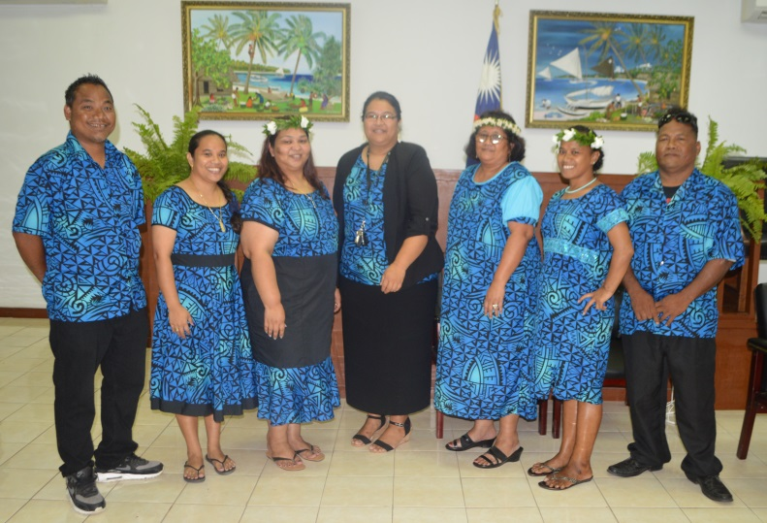
In 2018, the RMI Judiciary’s staff included the following: a chief clerk of the courts, a deputy chief clerk of the courts, five assistant clerks (one in Ebeye), three bailiffs (seconded from the National Police), and one maintenance worker. The chief clerk and four of the six assistant clerks were women. A listing of the judiciary personnel at the end of the year is attached as Appendix 2.

In addition to their administrative responsibilities, the clerks also serve as interpreters from Marshallese to English and English to Marshallese. The clerks also assist unrepresented court-users complete forms.

The Office of the Clerk of the Courts is open 8:30 a.m. to noon and 1:00 p.m. to 4:30 p.m., Monday through Friday, except holidays. In case of emergencies, the courts will open on weekends and holidays. The contact information for the Majuro and the Ebeye Courthouses is as follows:

Majuro Courthouse
P.O. Box B
Majuro, MH 96960
Tel.: (011-692) 625-3201/3297
Email: Marshall.Islands.Judiciary@gmail.com

The Majuro Courthouse is located in Uliga Village, Majuro Atoll, across from the Uliga Dock.

Ebeye Courthouse
P.O. Box 5944
Ebeye, Kwajalein Atoll, MH 96970
Tel.: (011-692) 329-4032
Email: ebeyecourthouse@gmail.com

The Ebeye Courthouse is located behind the Police Station on the Oceanside.

I. Professional Development and Regional Conferences

Managing the RMI Judiciary’s personnel in accordance with sound leadership and management practices is the fourth goal of the RMI Judiciary’s 2014-2018 Strategic Plan. Consistent with this goal, Strategies 4.1, 4.2, and 4.3, and internationally recognized practice, the RMI Judiciary in 2018 organized and facilitated professional development opportunities for both judges and court staff. All permanent justices and judges of the Supreme Court, the High Court, the Traditional Rights Court, and the District Court attended such workshops and conferences. Some of the Community Court judges observed the District Court's proceedings while they were in Majuro for other reasons. All seven clerks attended professional development workshops. The participants found that the programs met or exceeded their expectations, and addressed recognized training needs. Funding for such programs came from the RMI Judiciary’s annual operating budget, the Compact of Free Association, New Zealand, and Australia. The RMI Judiciary’s 2018 professional development activities are set forth below.

All three full-time judges (Chief Judge Walter Elbon, Associate Judge Nixon David, & Associate Judge Grace Leban) and pro tem judge Risi Graham from the Traditional Rights Court and all three judges from the District Court (Presiding Judge Milton Zackios, Associate Judge Ablos Paul, & Associate Judge Davidson Jajo) participated in the Pacific Islands Legal Institute Ethics Session for lay judges, held in Pohnpei, FSM from January 9-13, 2018.

District Court Associate Judge Davidson Jajo, Assistant Clerks Hainrick Moore and Item Note attended the Pacific Judicial Strengthening Initiative’s Promoting Substantive Justice Thematic Training of Trainers Workshop held in Vanuatu from 12-16 February 2018. The objectives of the workshop were to build the capacity of PIC courts to improve quality of substantive justice, familiarize participants with the contents of the Human Rights Toolkit, the Gender & Family Violence Toolkit, the Enabling Rights & Pro se Litigants Toolkit, and for the participants to plan & develop their own justice improvement plans.

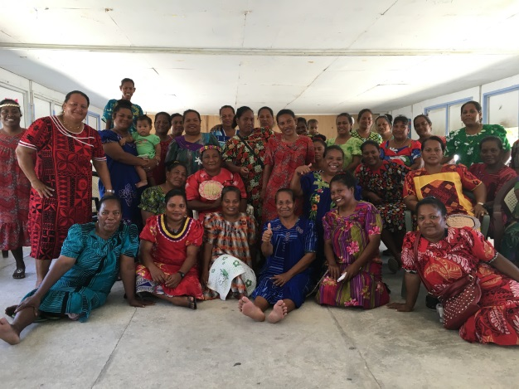
The Marshall Islands Judiciary and the Pacific Judicial Strengthening Initiative (PJSI) hosted a local Access to Justice Workshop in Majuro, Marshall Islands, from 14-16 March 2018. The Workshop was very well attended by fifty members of the community, prosecutors, defenders and members of the bar together with the judges and court staff from the High, District and Traditional Rights Courts of the Marshall Islands. Prior to this workshop, other community consultations had also been conducted on remote islands including Ebeye, Ebadon, and Mejatto in Kwajalein Atoll and Arno Atoll by PJSI’s Dr. Livingston Armytage and a team of judges and staff from the courts. The aim of the workshop was to provide outreach and an opportunity for the community to supply feedback to address unmet needs to improve the quality of the justice administered by the courts. The workshop provided a valuable forum to exchange experience and assess public satisfaction with access to justice and court services. This workshop is one of the many conducted by the Pacific Judicial Strengthening Initiative across the region. The initiative is funded by New Zealand Ministry of Foreign Affairs and Trade which has supported promoting the rule of law across the Pacific over recent years. Following the private consultations (on both Ebeye and Majuro) and the public meeting on Wednesday, the court judges and staff conducted their own workshop on Thursday and Friday to address/respond to the issues that arose from the consultations and public meeting.

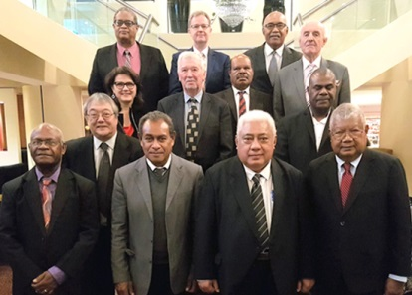
From the 16-18 April 2018, the Honorable Chief Justice Dame Sian Elias of New Zealand, as represented by Justice Helen Winkelmann hosted a high-level Forum of Chief Justices in Auckland – the 3rd Chief Justices’ Leadership Forum. The Forum was attended by 13 Chief Justices or their representatives. The fourth IEC was held on 19 April and attendees reviewed PJSI progress, provided feedback and direction. Noting the positive progress of the USP Certificate of Justice, plans were also laid for future initiatives. High Court Chief Justice Carl B. Ingram attended both events.

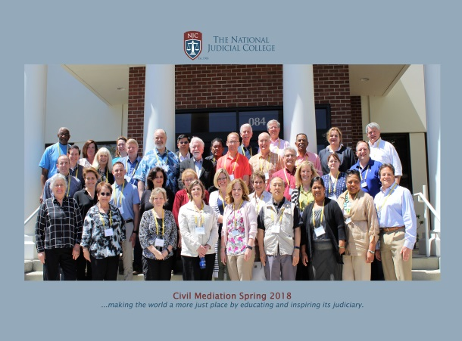
Two Traditional Rights Court judges (Chief Judge Walter K. Elbon and Associate Judge Grace L. Leban) attended the National Judicial College Court course “Civil Mediation” scheduled for May 7-11, 2018, in Reno, Nevada. Mediation is an important option in every system of justice. Judges with mediation skills can have opportunities open up to them both on and off the bench. This five day, 40-hour course is hands-on, interactive, fast-paced and practical. Simulations, interpersonal skill development and role play enable participants to integrate communication and problem-solving techniques for effective mediation management, thus avoiding classic errors. Upon completion, the participants, including the two TRC judges, received a certificate honored by most states with mediator credential requirements.

Supreme Court Chief Justice Daniel Cadra attended the 2018 Ninth Circuit Judicial Conference from July 23 to 26, 2018, in Anaheim, California. The sessions included the following: the Supreme Court Review; the Rise and Fall of Free Speech in the West; Amateurs No. More? The Legal Rights of the 21st Century Athlete; Law of Leaks; Block Chain: How an Anonymous Invention Could Change the World; When the Judges Disagree: A Discussion of Differences of Opinion Within the Circuit; Upward Trends in Fentanyl Criminal Cases and the Use of Cryptocurrency on the Dark Web; Pacific Island Committee; The Opioid Crisis: Its Genesis, National Implications, and Potential Solutions; Improving Access to Justice for Pro Se Litigants; Taking the War Out of Our Words; The Rule of Law: Practice versus Theory, with Stories from the Conflict Zones; The Top Ten Practical Tips to Mitigate Digital Risk When Traveling Abroad; Thinking Out Loud About Sentencing: Why We Do What We Do; The Workplace Challenge: Putting Good Policies and Good Intentions Into Practice; Law of War: Current Challenges and Operations in the Pacific Fleet; Conversion with the Justice; and Closing Remarks.

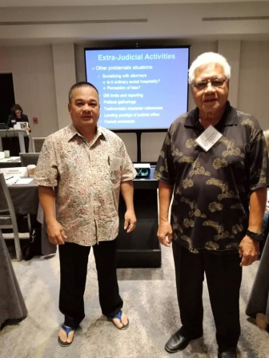
The Marshall Islands District Court judges (Presiding Judge Milton Zackios and Associate Judge Ablos T. Paul) attended the National Judicial College Court course “Decision Making” scheduled for August 6-9, 2018, in San Diego, CA. Each and every day, judges are called upon to make decisions that affect the lives of the persons coming before them. This course familiarized judges with many of the factors that affect the judicial decision-making process and assists judges in analyzing their own thinking and style. During the course, the faculty covered the psychology of decision making, explored how personality type may influence decision making, reviewed ethical considerations that may impact decision making, discussed how appellate courts review decisions, and provided practical suggestions to aid in making decisions from the bench.

Marshall Islands District Court judges (Associate Judge A. Tarry Paul, and Associate Judge Davidson T. Jajo) participated in the Federated States of Micronesia Judicial Conduct and Ethics Workshop, held in Palikir, Pohnpei August 28-31, 2018. The workshop covered the Bangalore Principles of Judicial Conduct. Discussion and analysis also took place on the Model Code of Judicial Conduct of the American Bar Association (ABA) and Article 11 of the United Nations (UN) Convention against Corruption (UNCAC). The workshop used case studies raising ethical questions discussed in small groups, with each group presenting their resolution of issues raised in hypothetical questions.

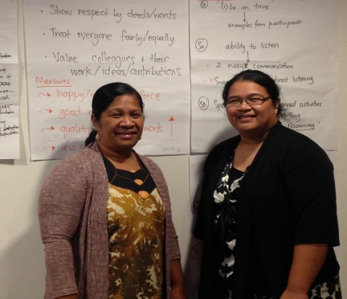
From 19-21 September 2018, TRC Associate Judge Grace Leban and Chief Clerk of the Courts Ingrid Kabua attended the second PJSI regional Judicial and Court Leadership Workshop in Auckland, New Zealand. This second workshop built on the outcomes of the first Leadership Workshop held in Tonga in September 2017 (attended by High Court Associate Justice Colin Winchester). The objectives of the workshop were to share experience on what judicial leadership means in the Pacific, know and understand key concepts of inspirational judicial/court leadership, identify and develop strategies to address challenges in implementing leadership action plans, and to develop/refine Leadership Action Plans (developed in the first Leadership Workshop) that promote partner courts’ defined vision and mission. On the first day all courts had to deliver a 10 minute presentation on the country Leadership Plans developed in Tonga: what were the outcomes/change(s) it was aiming to achieve, what had been achieved/done under the plan to-date, and what the challenges/issues the courts have experienced with implementing the plan? The Marshall Islands leadership action plan developed by Associate Justice Winchester was to make amendments to the Domestic Violence Protection Act to improve the process of obtaining protection orders and increasing overall the level of protection.

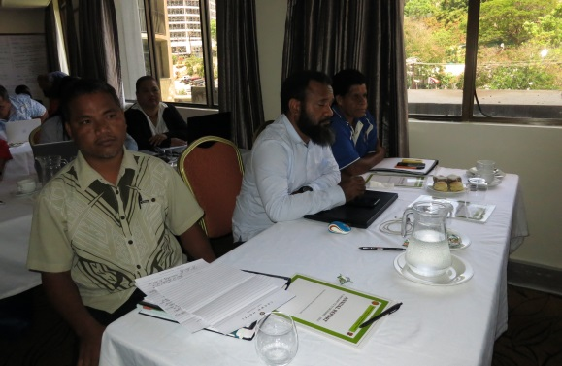
From 26-30 November, 2018 Assistant Clerk of the Courts Hainrick Moore attended the Regional Building Capacity in Managing Court Data Workshop held in Port Moresby, Papua New Guinea. The workshop objectives were for participants to know and understand what data is needed to enable efficient management, performance monitoring and accountability, to understand the processes and approach to developing systems and procedures to collect integrate and manage quality data, and to develop a Court Data Management Plan to collect, analyze, and use data.

J. Court Rules and Relevant Statutes

To enhance access to justice, the RMI Judiciary regularly reviews and amends or seeks amendments of its rules of procedure, Evidence Act, and other statutes.

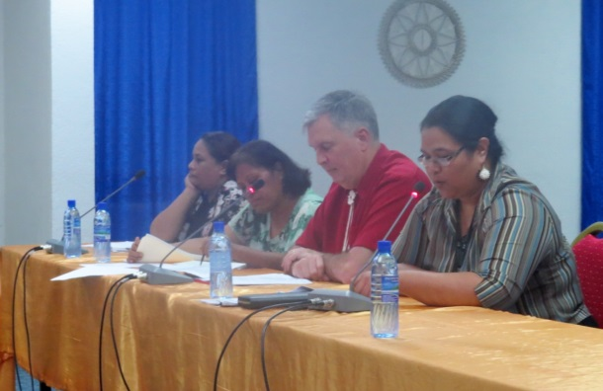
Over the past 10 years, the RMI Judiciary has proposed more than 35 amendments to Acts. In 2018 the Nitijela adopted 10 Acts drafted by the RMI Judiciary: the Uniform Foreign Money-Judgment Recognition Act (Amendment) Act 2018; the Judiciary (Amendment) Act 2018 to amend the long-arm provisions; the UNCITRAL Model Law on Cross-Border Insolvency Implementation Act 2018; the UNCITRAL Model Law on International Commercial Arbitration Act 2018; the Enforcement of Judgment (Technical Amendment) Act 2018; the Restatements of the Law (Reference) Act 2018; the Uniform Commercial Code (Reference) Act 2018; the Uniform Voidable Transactions Act; Legal Profession (Amendment) Act of 2018; and the Adoptions (Amendment) Act 2018.

The RMI Judiciary proposed two other Acts, which are scheduled to be considered by the Nitijela in 2019: the Judicial Compensation (Amendment) Act 2018 to increase the salary of District Court judges with law degrees; and the Domestic Violence Prevention and Protection (Amendment) Act 2018 to correct identified error and deficiencies in the existing act.

The RMI Judiciary also has been busy updating its rules. Over the past 10 years, the RMI Judiciary has amended its rules approximately 20 times. In 2018, the RMI Judiciary updated the Schedule of Costs and Fees, the Marshall Islands Supreme Court Rules of Procedure, the Marshall Islands Rules of Criminal Procedure, and, effective January 1, 2019, the Marshall Islands Rules of Civil Procedure.

IV. THE JUDICIAL SERVICE COMMISSION: JUDICIAL APPOINTMENTS

Along with the courts, the Constitution provides for a Judicial Service Commission, which consists of the Chief Justice of the High Court, as chair, the Attorney-General, and a private citizen selected by the Cabinet. The private member is Maria K. Fowler. The JSC nominates to the Cabinet candidates for appointment to the Supreme Court, High Court and TRC, and the Commission appoints judges to the District Court and the Community Courts. In appointing Community Court judges, the Commission takes into consideration the wishes of the local communities as expressed through their local government councils. The Commission also may make recommendations to the Nitijela regarding the qualifications of judges. In the exercise of its functions and powers, the Commission does not receive any direction from the Cabinet or from any other authority or person but acts independently. The Commission may make rules for regulating its procedures and generally for the better performance of its functions. The Commission also reviews complaint against judges.

In 2018, the Commission nominated to the Cabinet for re-appointment, two Supreme Court acting justices. Also, the Commission appointed a new presiding judge of the District Court to replace the retiring presiding judge and appointed or renewed the appointments of 11 Community Court judges.

V. ACCOUNTABILITY: CODES OF CONDUCT AND COMPLAINTS

The third goal of the RMI Judiciary’s Strategic Plan includes “to be accountable.” To enhance its transparency and accountability, the RMI Judiciary has adopted internationally recognized standards for judicial conduct and attorney conduct. These standards are available to the public as are the procedures for lodging complaints against judges, attorneys, and court staff.

With respect to judicial conduct, the RMI Judiciary has adopted the Marshall Islands Code of Judicial Conduct 2008 (revised January 9, 2017). The Code is based principally upon the Bangalore Principles and the American Bar Association model Code of Judicial Conduct. A copy of the RMI Judiciary’s code can be found on its website, www.rmicourts.org/ under the heading “The Marshall Islands and Its Judiciary.” The provisions for lodging and processing complaints against judges start on page 12 of the code.

In 2018, no complaints were lodged against the judges. In the past five years, only one complaint has been lodged against a judge. In late 2015, a litigant complained that a judge did not listen to her. In January 2017, the Judicial Service Commission resolved the matter finding no wrongdoing by the judge and referred the matter to the High Court Chief Justice to counsel the subject judge. This is the only complaint made in the past five years for all courts and all judges.

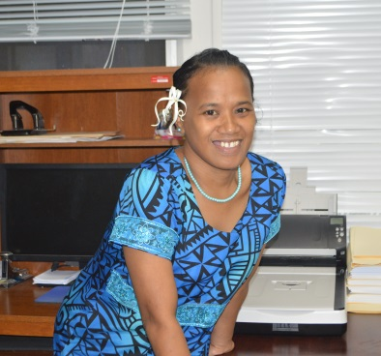
With respect to attorney conduct, the RMI Judiciary has adopted the American Bar Association’s Rules of Professional Conduct. Provisions for lodging and processing complaints against attorneys can be found on the RMI Judiciary’s website under the heading “Rules of Admission and Practice.” The Supreme Court and High Court have appointed an attorney-committee to hear complaints. In 2018, no complaints were lodged or pending against attorneys.

With respect to court staff, the RMI Judiciary maintains a complaint box at the courthouses. In 2018, no complaints were lodged against court staff. Nor have there been any complaints lodged against court staff within the past five years.

VI. FACILITIES, TECHNOLOGY, AND LIBRARY

Administering the RMI Judiciary’s buildings and equipment in accordance with sound management practices is the fifth goal of the RMI Judiciary’s Strategic Plan.

A. Facilities

Over the recent past, the RMI Judiciary, with funding from court fees and from the Cabinet, the Nitijela, and the Republic of China (Taiwan), has renovated the Majuro Courthouse and the Ebeye Courthouse to make them safe, secure, and accessible. The projects have included renovating the Ebeye Courthouse, adding a ground-floor courtroom at the Majuro Courthouse, renovating of the chambers of the Traditional Rights Court in Majuro, repainting the Majuro Courthouse and replacing the roof, and installing a 100KVA backup generator for the Majuro Courthouse.

In 2017, the RMI Judiciary built a police substation next to the Majuro Courthouse. In early 2018, the utilities were installed, and the National Police Department started manning the sub-station in March 2018.

Also, in 2017, the RMI Judiciary sought funding for a new courthouse on Ebeye. The Ebeye Courthouse building has deteriorated to the point where its needs to be replaced. It is in bad condition and cannot be expanded to meet the RMI Judiciary’s and Kwajalein community’s needs. Unfortunately, the RMI Judiciary did not receive the funds it requested. In 2018, the RMI Judiciary renewed its request for funds for this vital project, and in 2019 will do so again.

B. Technology

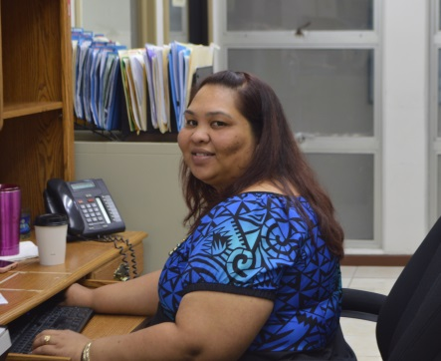
The courthouses on Majuro and Ebeye are equipped with computers, printers, and photocopiers and have Internet access (@ 7.0 Mbps in Majuro and 1.5 Mbps in Ebeye). The courts permit the filing and service of documents via email attachment. The computers in Majuro are linked together in a network, and the Majuro Courthouse has three scanners with OSC software permitting the courts to scan documents and send them almost anywhere in the world. Over the past four years, the RMI Judiciary has replaced all but three of its older computers. Those computers will be replaced in 2019. Software updates remain a critical need and from time-to-time computers crash and must be replaced.

Currently, the High Court permits off-island counsel to attend status and scheduling conferences via telephone and Skype. Occasionally, evidence in uncontested matters is taken via Skype or telephone. However, more band width is needed to provide stable video conferencing for contested matters.

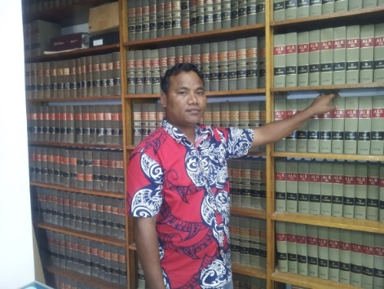
C. Library

The RMI Judiciary has a small, but functional, law library which includes hard copies of the following: United States Supreme Court cases through 2016; American Law Reports First, Second, Third, Fourth, part of Fifth, and Federal; LaFave on Criminal Law, Criminal Procedure, and Search and Seizure; Wharton on Criminal Law and Criminal Procedure; American Jurisprudence 2nd; Wright and Miller on Federal Practice and Procedure; Moore’s Federal Practice; some Restatements of the Law; and others. Also, the RMI Judiciary has up to date online access to United States case law and secondary sources through a WestLaw Internet subscription.

VII. ANNUAL BUDGET AND AUDIT REPORT

Managing the RMI Judiciary’s financial resources in accordance with sound financial practices is the sixth goal of the RMI Judiciary’s Strategic Plan. This is evidenced not only by the work of the courts, but also by the RMI Judiciary’s management of the funds made available to it.

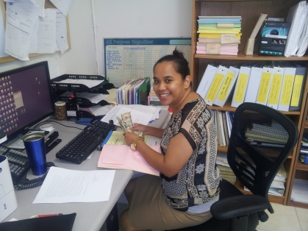
For FY 2018, the Nitijela appropriated $1,082,860 for the RMI Judiciary: $747,078 for salaries and wages and $335,782 for all others. Less audit expenses of $8,596 paid out by the Ministry of Finance, a total of $327,186 was paid to the RMI Judiciary for its operational funds.

Of the $747,078 appropriated for personnel in FY 2018, the RMI Judiciary only expended $679,065.49 because of vacancies and unexpended salaries in the High Court and the Community Courts. The unspent personnel funds from FY 2018, $68,012.51, remained in the General Fund with the Ministry of Finance.

Of the $335,782 appropriated in FY 2018 for all other expenses, $8,596 was retained by the Ministry of Finance for audit expenses and the RMI Judiciary expended or obligated the remaining $327,186.

From operations funds, the RMI Judiciary has segregated moneys the Nitijela appropriated for the Legal Aid Fund. As of September 30, 2018, the RMI Judiciary had $275,330.59 in its Legal Aid Fund account, much of which had been obligated for payment to attorneys to represent those who cannot offer an attorney and cannot be represented by the Micronesian Legal Aid Services Corporation and the Office of the Public Defender.

Apart from Nitijela appropriations, the RMI Judiciary by Act has its own special revenue fund (“RMI Judiciary Fund”). Court fines and fees (excluding national criminal fines and local government fines) collected by the Office of the Clerk of the Courts are deposited into this fund, as are funds from other sources. Collections by the Office of the Clerk of the Courts and deposited into the RMI Judiciary Fund in FY 2018 totaled $77,020.84. As highlighted in the Significant Events or Accomplishments section of this report (page 6), funding for the construction of a police sub-station at the Majuro Courthouse was made possible through the RMI Judiciary Fund. The fund balance at the end of FY 2018, $190,006.99 and monies collected in FY 2018 will be reserved for a new Ebeye courthouse. The Ebeye Courthouse project is in the planning stage and most certainly will need much more additional funding.

For the Marshall Islands Judiciary Fund, Deloitte for FY 2018 reported a clean audit with one finding. Attached as Appendix 3 is the statement of revenues, expenditures, and changes in the RMI Judiciary Fund balance for years ended September 30, 2018 and 2017, the Balance Sheets for years ending September 30, 2018 and 2017, and the Schedule of Finding(s) and Responses.

Appendix 1

ORGANIZATIONAL CHART
FOR THE
MARSHALL ISLANDS JUDICIARY

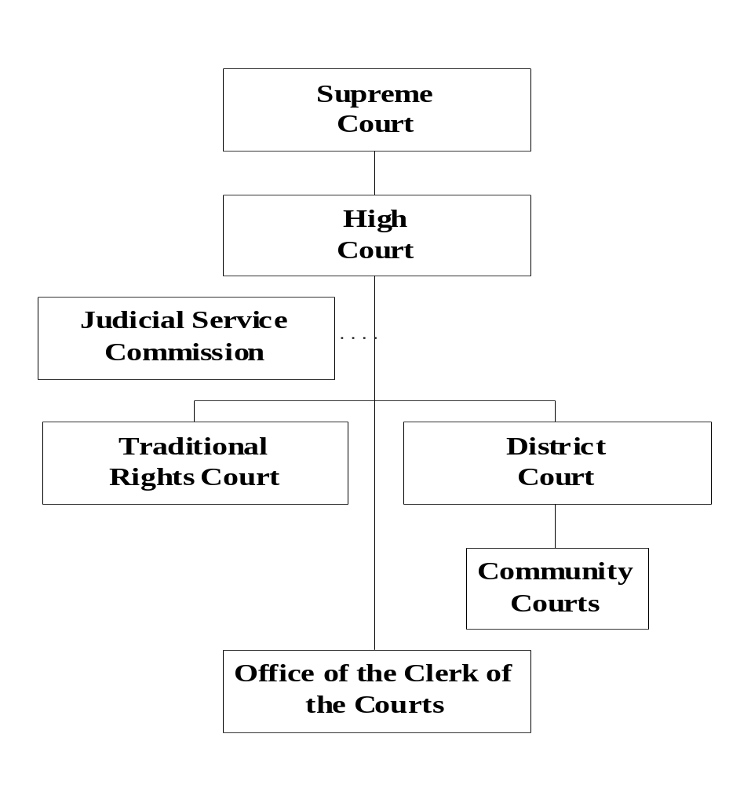

Appendix 2

JUDICIARY PERSONNEL

Justices and Judges

Supreme Court Chief Justice Daniel N. Cadra (9/21/13-9/20/23)

High Court Chief Justice Carl B. Ingram (10/5/13-10/4/23)
High Court Associate Justice Colin R. Winchester (11/3/16-11/2/18)
High Court Associate Justice Witten T. Philippo (10/29/17-1/31/30)

Traditional Rights Court Chief Judge Walter K. Elbon (7/04/10-7/03/20)
Traditional Rights Court Associate Justice Nixon David (4/7/17-4/6/21)
Traditional Rights Court Associate Justice Grace L. Leban (7/04/10-7/03/20)

Presiding District Court Judge Milton Zackios (4/5/15-12/25/18)
Associate District Court Judge A. Tarry Paul (11/30/15-12/25/18)
Presiding District Court Judge A. Tarry Paul (12/26/18-12/25/28)
Associate District Court Judge Davidson T. Jajo (Ebeye) (4/18/16-4/17/26)
Associate District Court Judge (Vacant)

Ailinglaplap Community Court Presiding Judge Canover Katol (5/4/18-5/3/24)
Ailinglaplap Community Court Associate Judge (vacant)
Ailinglaplap Community Court Associate Judge Mannu Rakin (7/13/18-7/12/24)
Ailuk Community Court Presiding Judge Tilly Menuna (2/25/18-2/24/24)
Arno Community Court Presiding Judge Batle Latdrik (08/05/18-08/04/24)
Arno Community Court Associate Judge Patrick Jiraal Alfred (08/05/18-08/04/24)
Arno Community Court Associate Judge Benjinej Kawe (08/05/18-08/04/24)
Aur Community Court Presiding Judge Benty Jikrok (03/03/17-03/02/23)
Bikini and Kili Community Court Presiding Judge Kener Lewis (4/18/16-4/17/22)
Ebon Community Court Presiding Judge Jurelon Alik (09/17/17-09/16/23)
Enewetak and Ujelang Community Court Presiding Judge (vacant)
Jabat Community Court Presiding Judge Tari Jamodre ((8/7/16-8/6/22)
Jaluit Community Court Presiding Judge Hertina Mejjena (7/13/14-7/12/18)
Jaluit Community Court Associate Judge Junior Helmi Morris (01/22/17-01/21/23)
Lae Community Court Presiding Judge Island Langbata (12/03/18-12/02/24)
Lib Community Court Presiding Judge (vacant)
Likiep Community Court Presiding Judge Riton Erakdrik (07/25/16-07/24/22)
Maloelap Community Court Presiding Judge Elji Lelwoj (02/25/18-02/24/24)
Maloelap Community Court Associate Judge Jobo Lauror (02/25/18-02/24/24)
Mejit Community Court Presiding Judge Rebecca John (1/25/15-1/24/21)
Mili Community Court Presiding Judge Jiton John (01/22/17-01/21/23)
Namdrik Community Court Presiding Judge Reio Lolin (08/26/18-08/25/24)
Namu Community Court Presiding Judge (vacant)
Rongelap Community Court Presiding Judge (vacant)
Ujae Community Court Presiding Judge Area Jibbwa (08/26/18-08/25/24)
Utrik Community Court Presiding Judge Jackel Moore (09/17/17-09/16/23)
Wotho Community Court Presiding Judge Carlmai Antibas (9/23/16-9/22/22)
Wotje Community Court Presiding Judge Anjain Helbi, (5/ 27/18-5/26/24)
Wotje Community Court Associate Judge Mejwadrik Elbon (8/9/15-8/8/21)
Unallocated (vacant)

Judicial Service Commission

High Court Chief Justice Carl B. Ingram, Chair
Attorney-General Filimon M. Manoni, Member
Maria K. Fowler, Member Representing the Public

Staff

Chief Clerk of the Courts Ingrid K. Kabua
Assistant Clerk of the Courts Armen Bolkeim (Ebeye)
Assistant Clerk of the Courts Hainrick Moore
Assistant Clerk of the Courts Tanya Lomae
Assistant Clerk of the Courts Ronna Helkena
Assistant Clerk of the Courts Maureen Milne
Assistant Clerk of the Courts Kristen Kaminaga
Bailiff Jukku Benjamin, Sergeant
Bailiff Moses Lautiej, Police Officer I
Bailiff Noland Tash, Policer Officer I
Maintenance James Milne

Appendix 3

MARSHALL ISLANDS JUDICIARY FUND

Statements of Revenues, Expenditures, and Changes in Fund Balance
Years Ended September 30, 2018 and 2017
 | 2018 |  | 2017
Revenues:
Nitijela appropriation | $ 1,006,252 |  | $ 950,281
Court fines and fees | 129,334 |  | 95,884
Interest | 2,322 |  | 1,829
Other | 15,617 |  | 40,007
Total Revenues | 1,153,525 |  | 1,088,001
Expenditures:
Salaries, wages, and benefits | 679,065 |  | 638,398
Capital outlay | 106,021 |  | 8,069
Leased housing | 72,000 |  | 71,250
Supplies and materials | 48,167 |  | 44,559
Communications | 45,244 |  | 37,873
Travel | 42,473 |  | 53,578
Professional services | 40,774 |  | 28,515
POL | 10,802 |  | 11,110
Repairs and maintenance | 6,362 |  | 8,190
Training | 6,289 |  | 10,935
Insurance | 5,554 |  | 1,982
Subscriptions | 5,060 |  | 4,038
Miscellaneous | 7,118 |  | 16,310
Total expenditures | 973,840 |  | 973,840
Net change in fund balance | 41,357 |  | 114,161
Fund balance at the beginning of the year | 431,121 |  | 316,960
Fund balance at the end of the year | $ 472,478 |  | $ 431,121
See accompanying notes to financial statements.

Balance Sheets
September 30, 2018 and 2017
 | 2018 |  | 2017
ASSETS
Cash | $ 471,257 |  | $ 432,457
Accounts receivable | $ 2,146 |  | $ 4,269
 | $ 473,403 |  | $ 436,726
LIABILITIES AND FUND BALANCE
Liabilities:
Other liabilities and accruals | $ 925 |  | $ 5,605
Contingency
Fund balance:
Committed | $ 472,478 |  | $ 431,121
Total liabilities and fund balance | $ 473,403 |  | $ 436,726
See accompanying notes to financial statements.

MARSHALL ISLANDS JUDICIARY FUND
Schedule of Findings and Responses
Year Ended September 30, 2018

Finding No.: 2018-001
Area: Financial Reporting
Criteria: Timely financial reporting should be facilitated by internal control conducive to the preparation and independent review of reconciliations of significant general ledger accounts.

Condition: The Judiciary did not close fiscal year September 30, 2018 financial information (trial balance and subsidiary ledgers) until March 12, 2019.

Cause: The cause of the above condition is the lack of timely closing of the year-end financial statements with review and reconciliation of significant general ledger accounts.

Effect: The effect of the above condition is the non-timely provision of trial balance for audit.

Recommendation: We recommend that the Judiciary implement internal control procedures to facilitate timely general ledger reconciliation processes.

Auditee Response and Corrective Action Plan: The Judiciary agrees with the auditor’s comments and recommendation. The following actions will be taken to correct or improve the situation. It will be the Chief Clerk’s responsibility to ensure that the reconciliation of the Judiciary’s bank accounts is carried out by the Financer Officer at the end of each month. In case of technical difficulties (a major cause of the delay/current finding), a manual reconciliation shall be performed (outside Quickbooks) using the Judiciary’s backup excel spreadsheets and the documents supporting the reconciliation shall be printed and certified.

Appendix 4

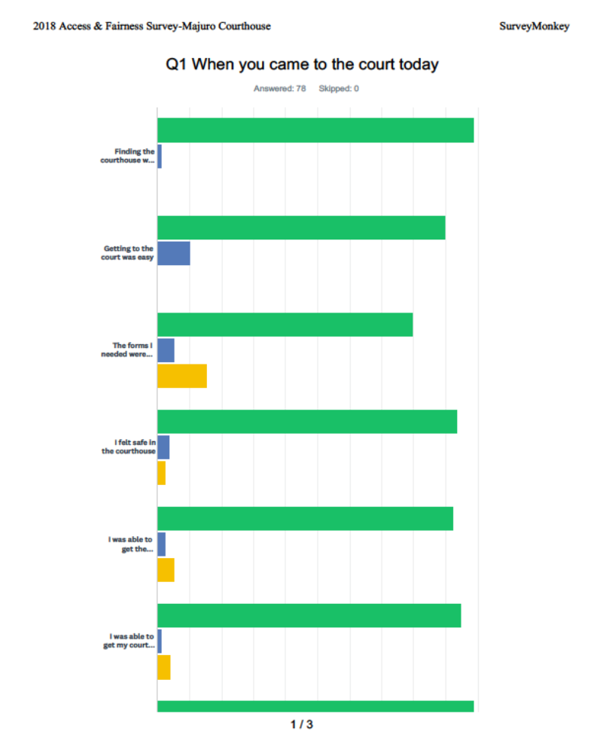
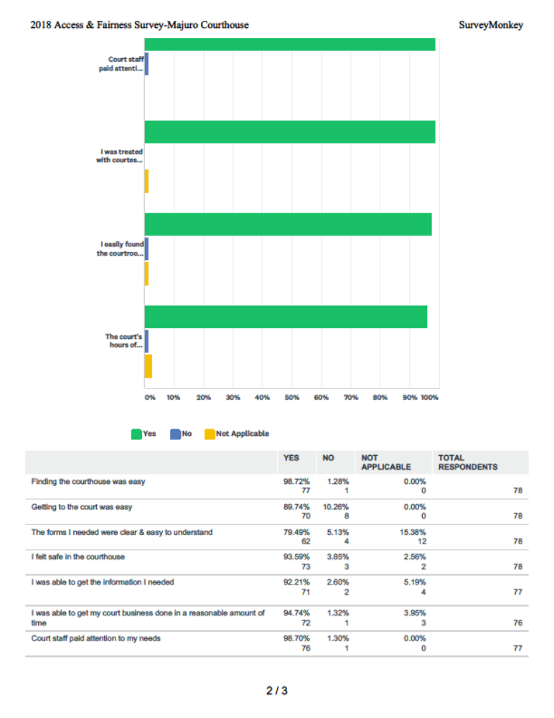
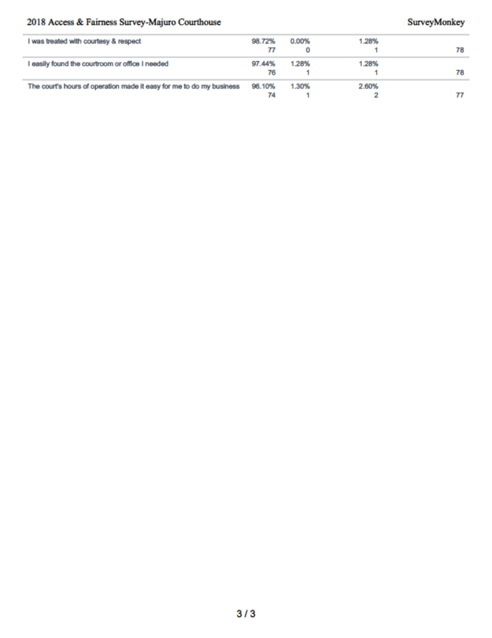
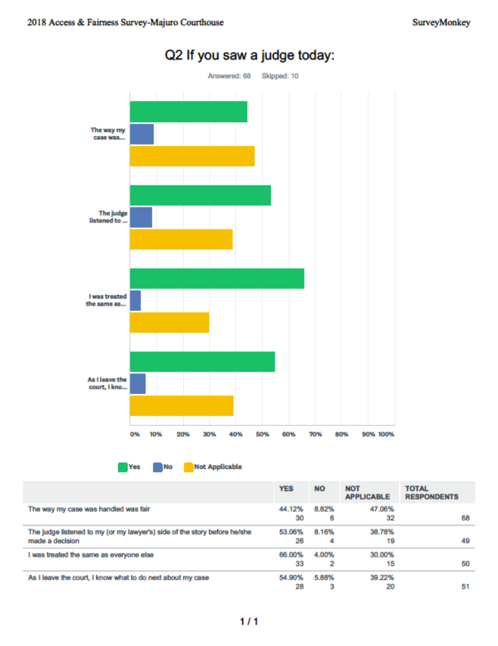
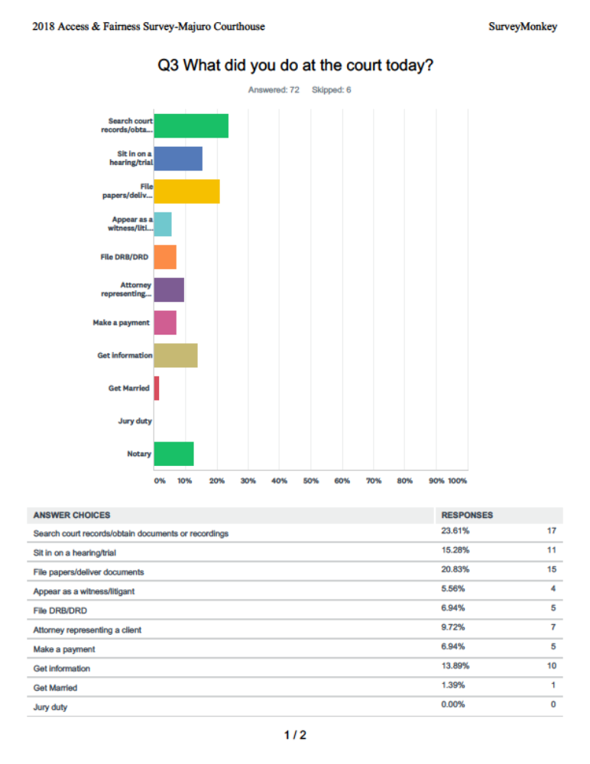
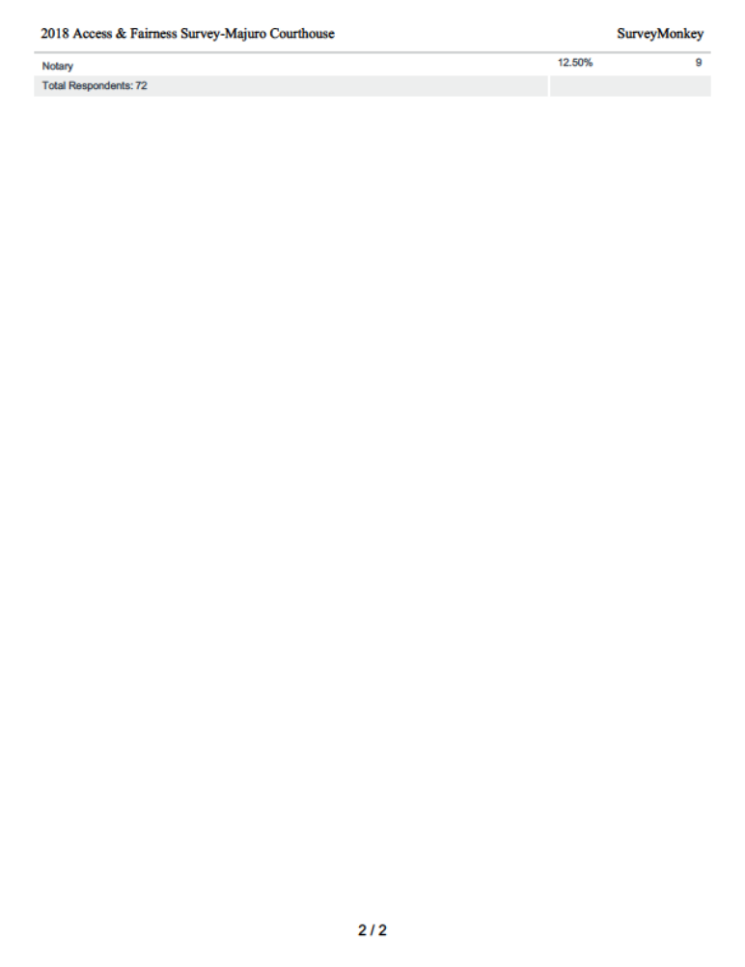
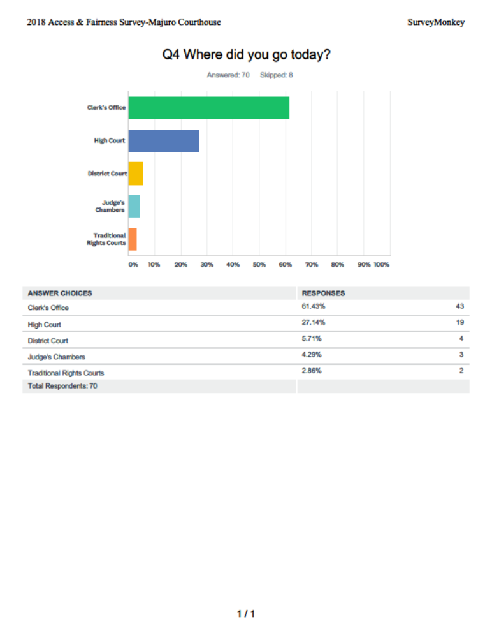
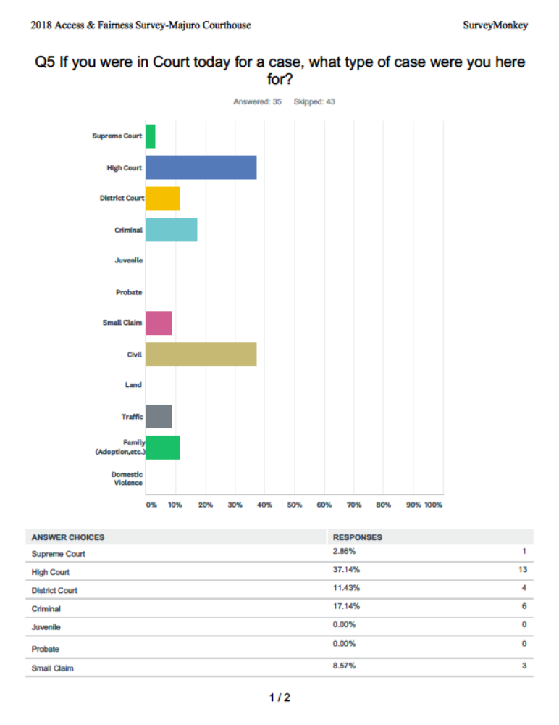
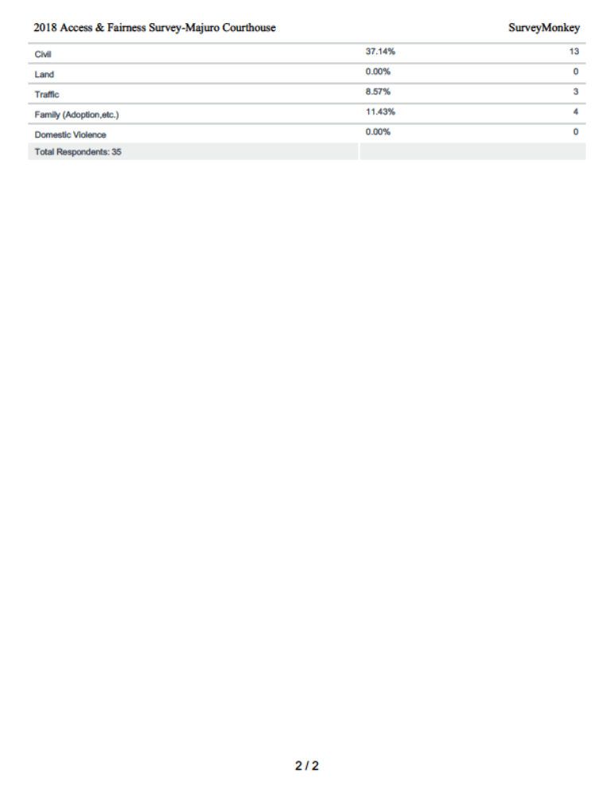
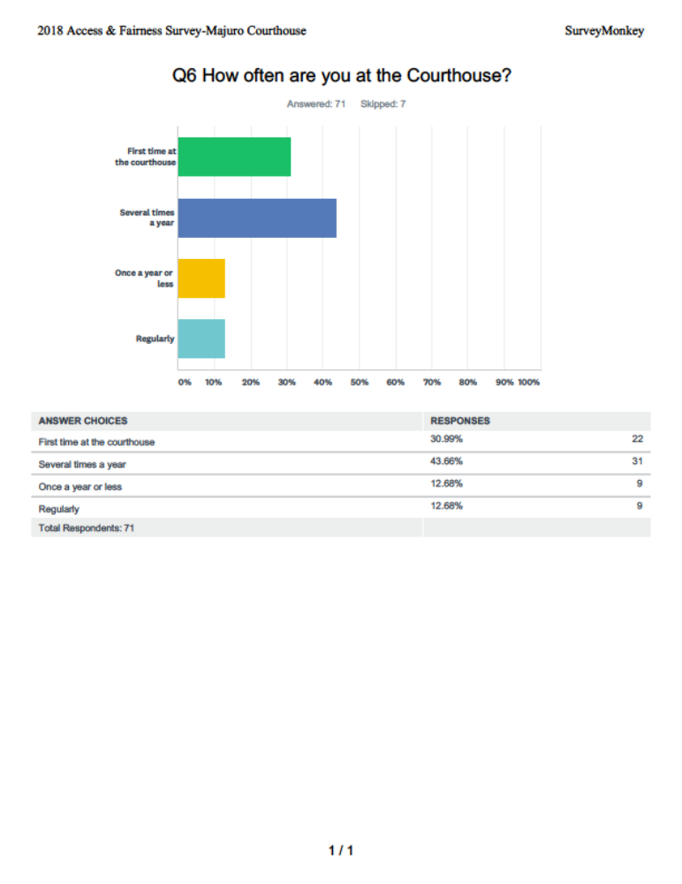
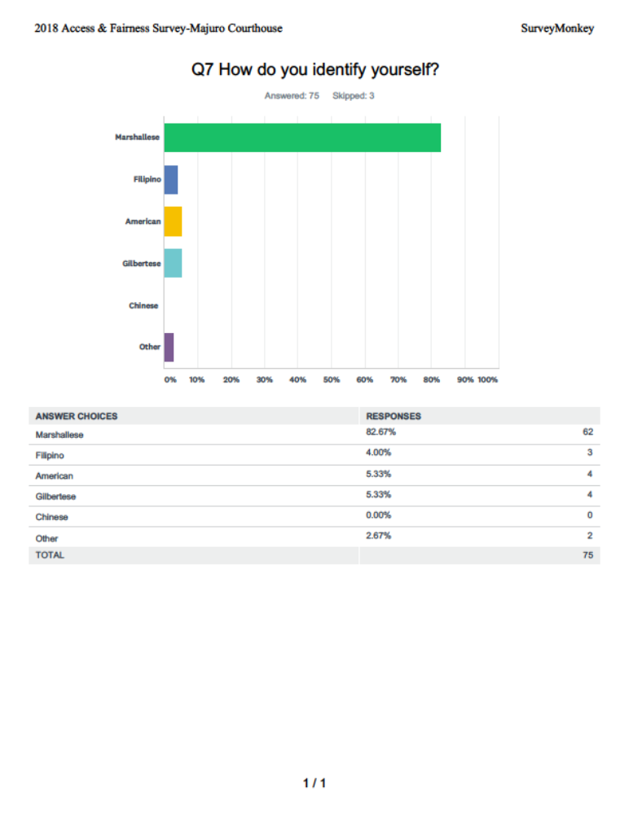
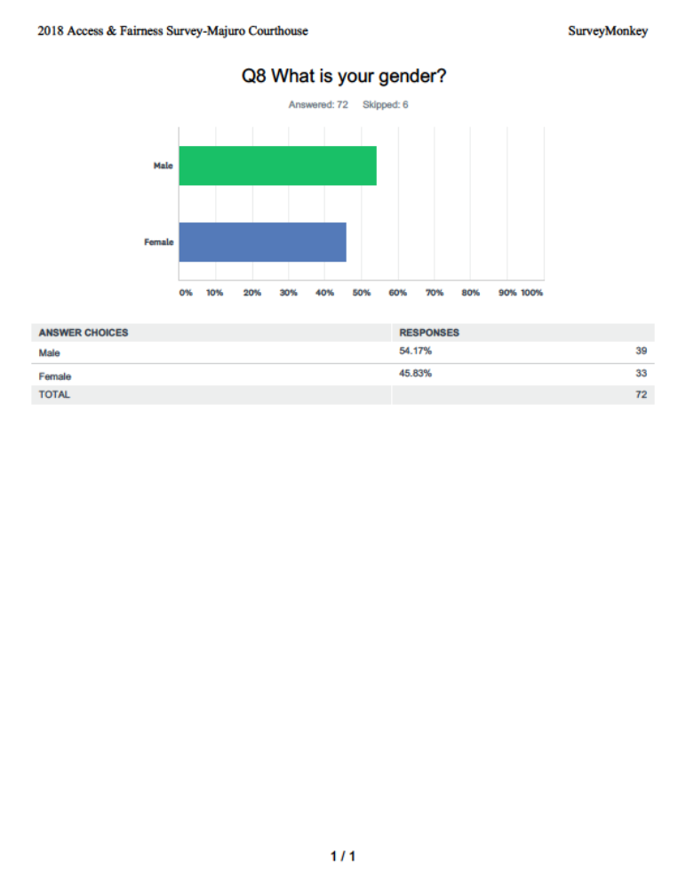
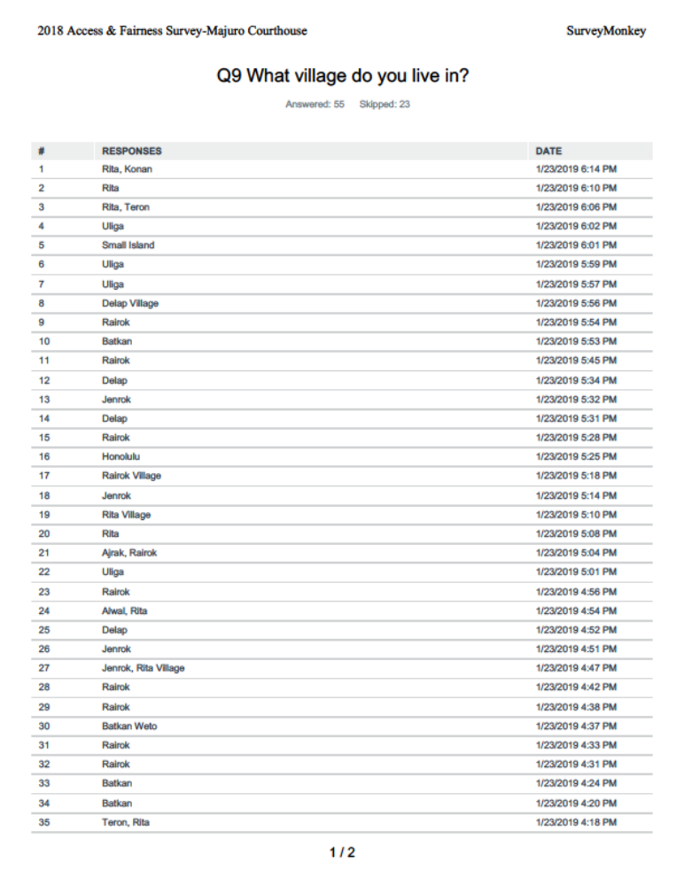
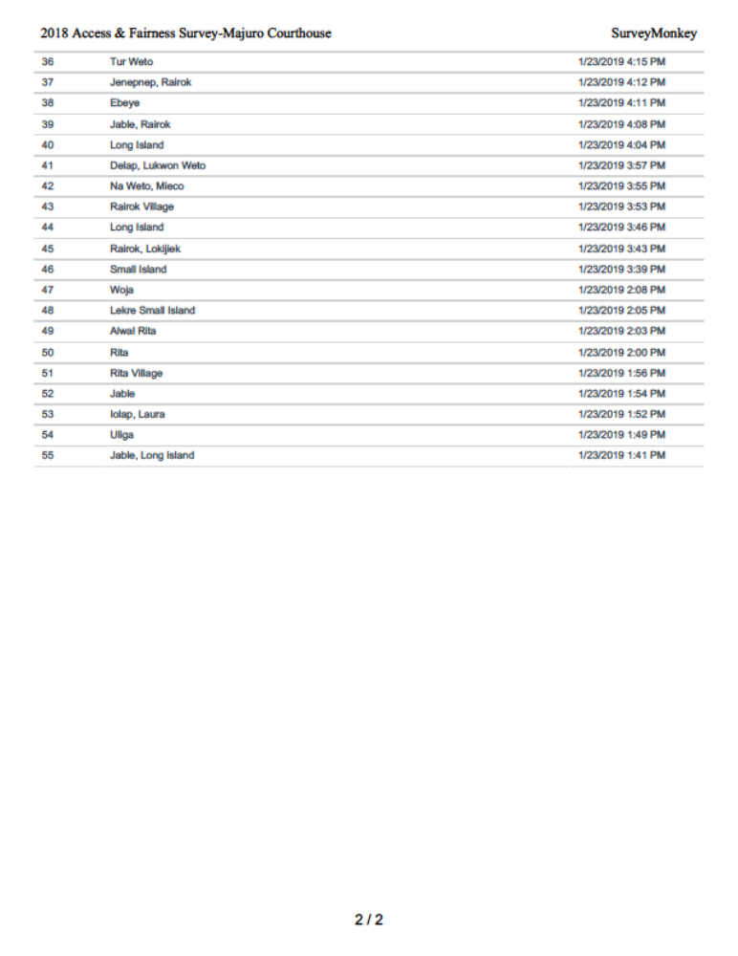
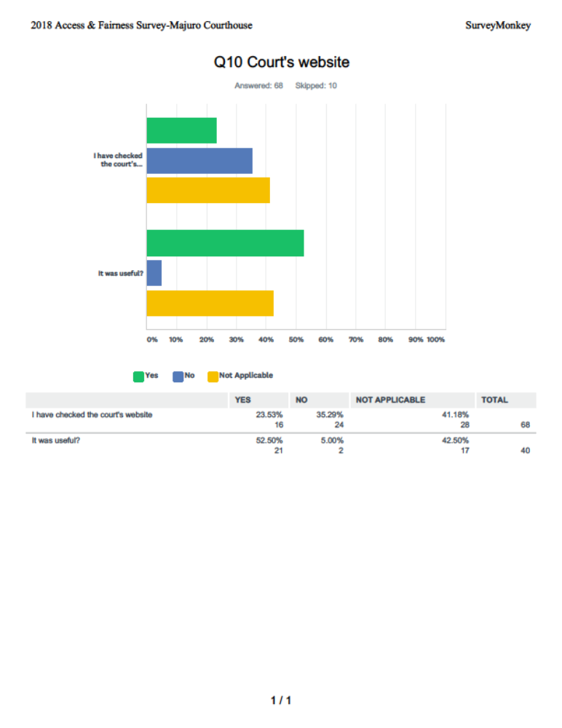
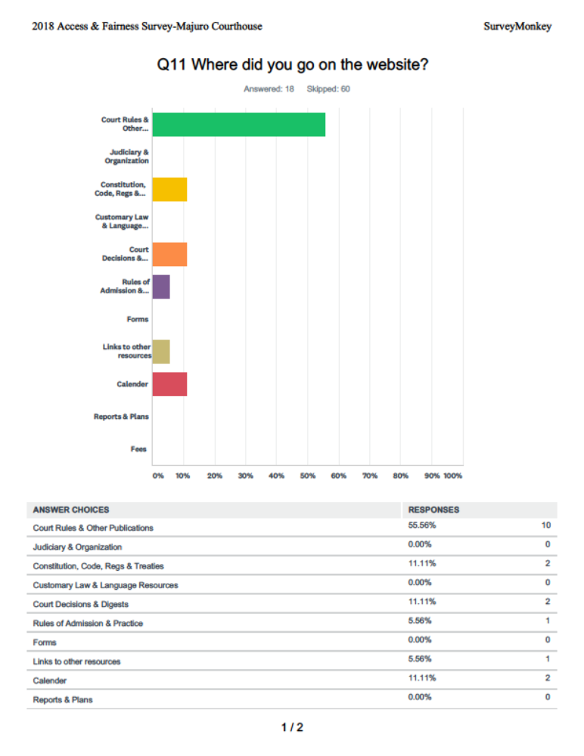
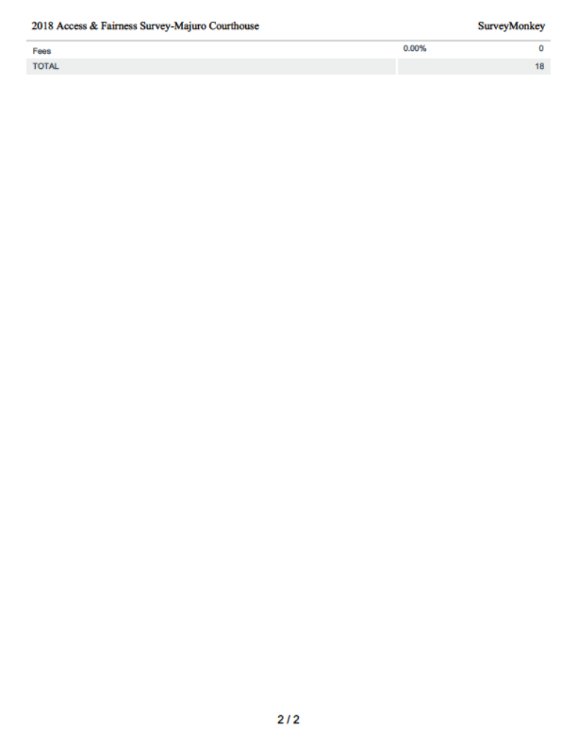
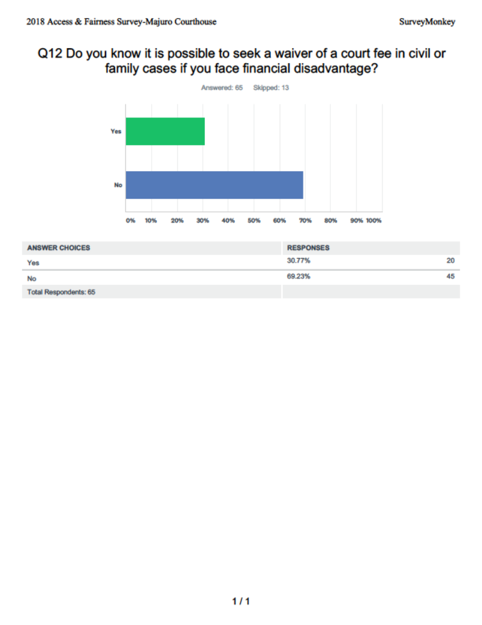
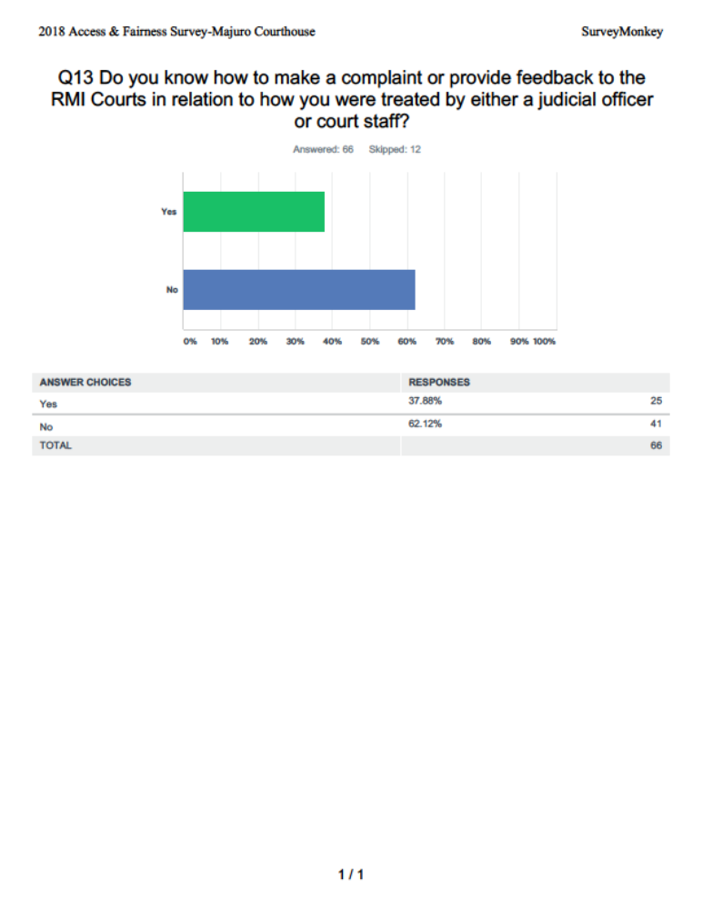
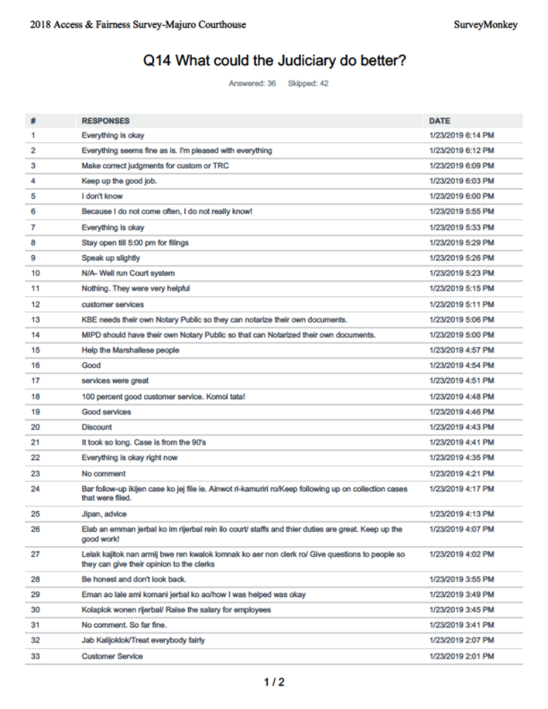
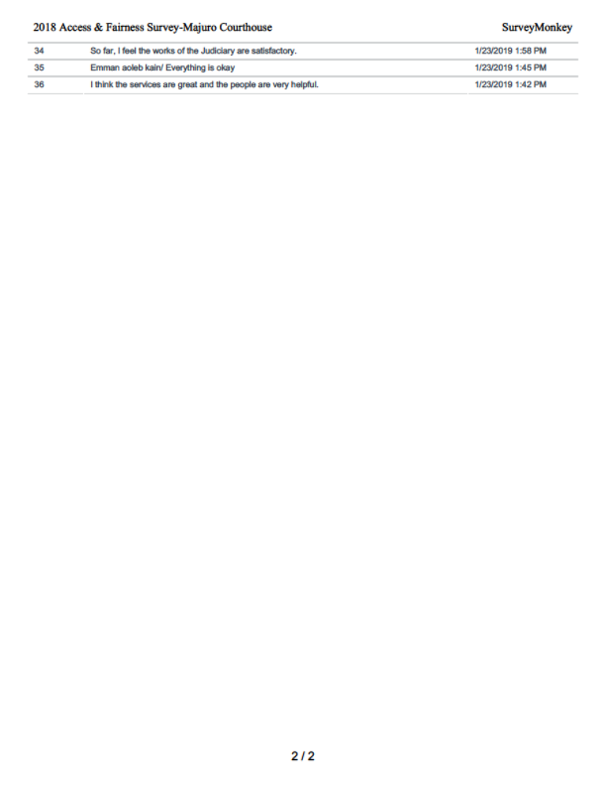
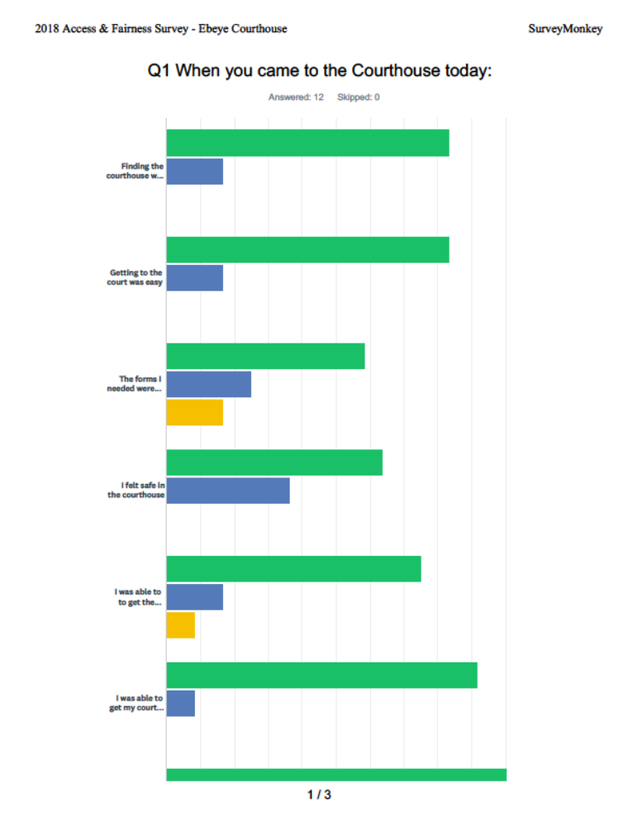
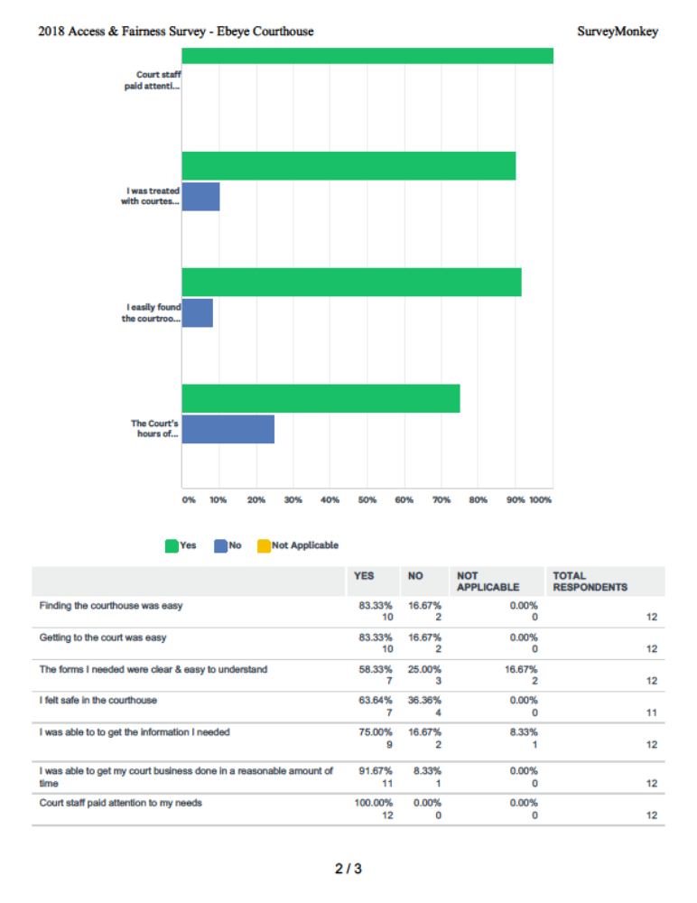
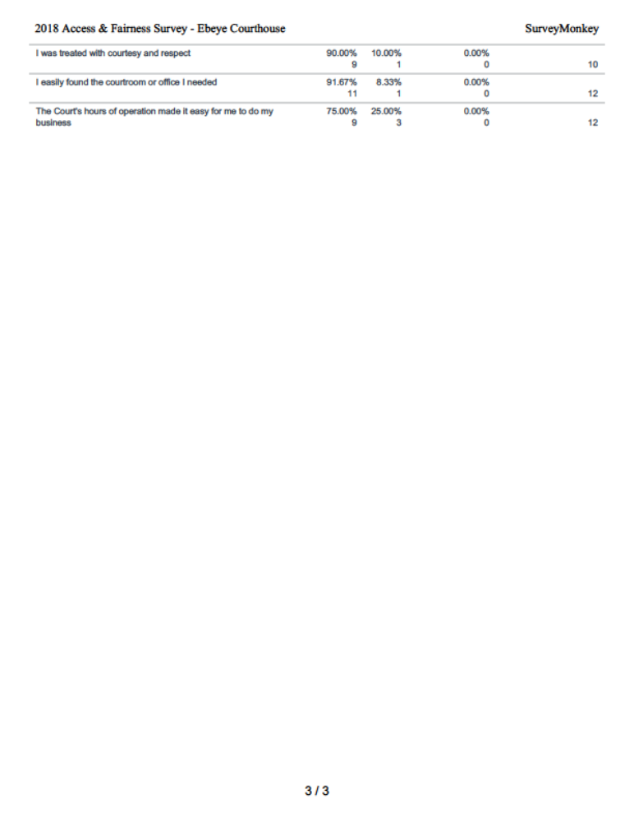
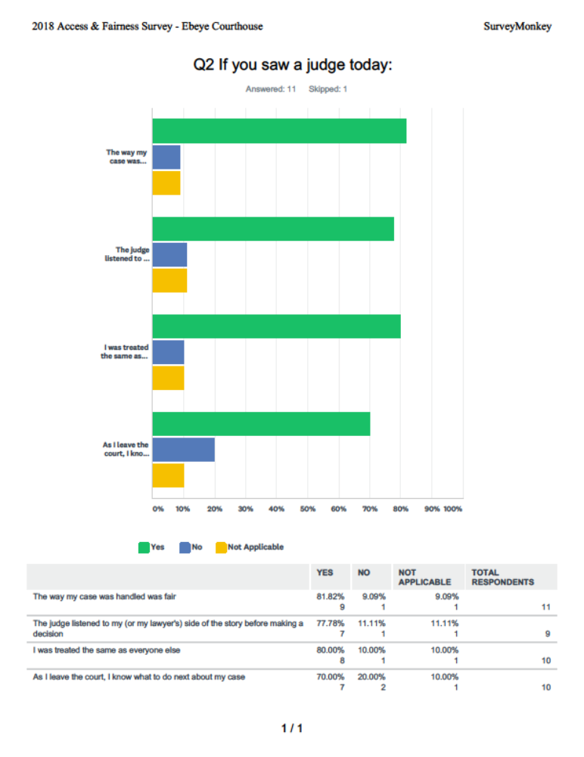
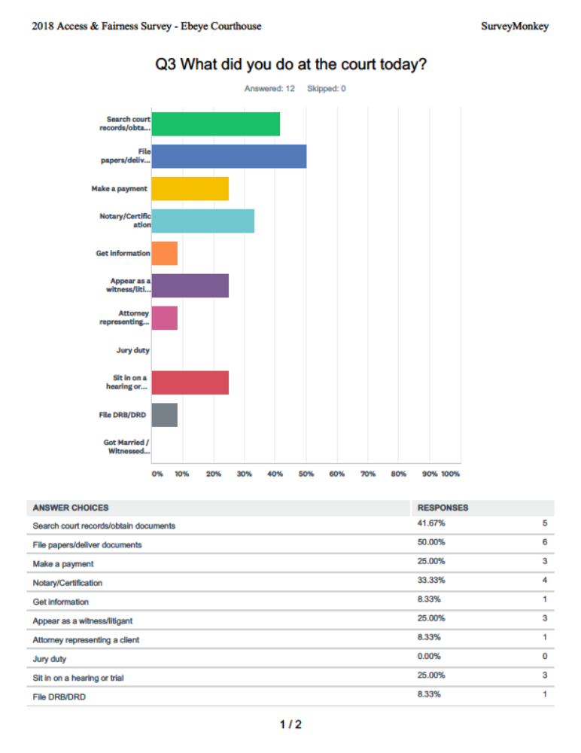
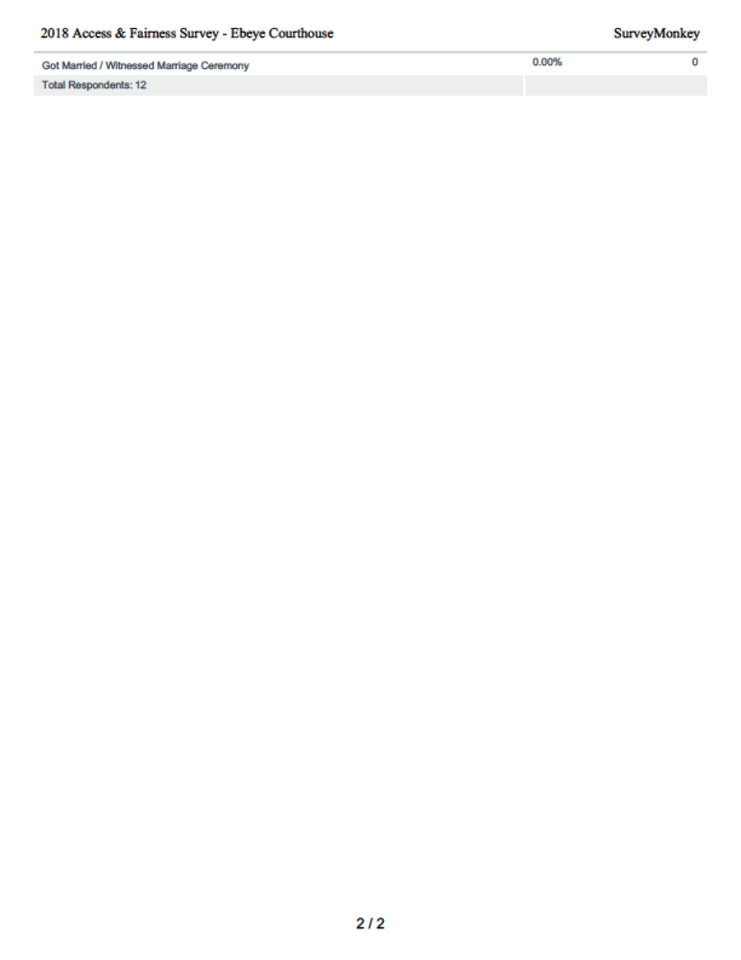
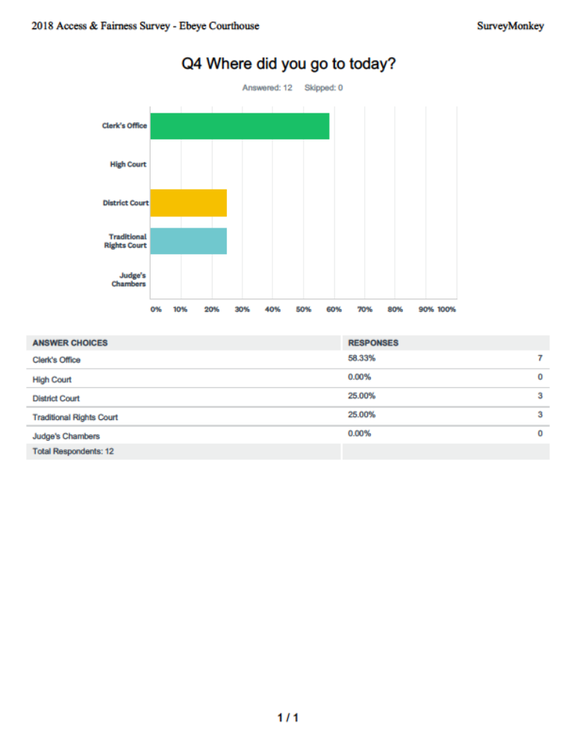
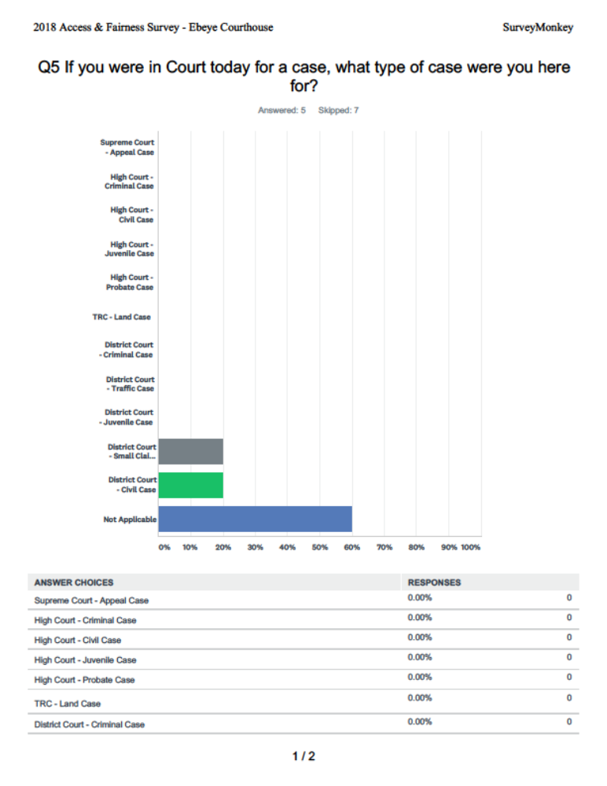
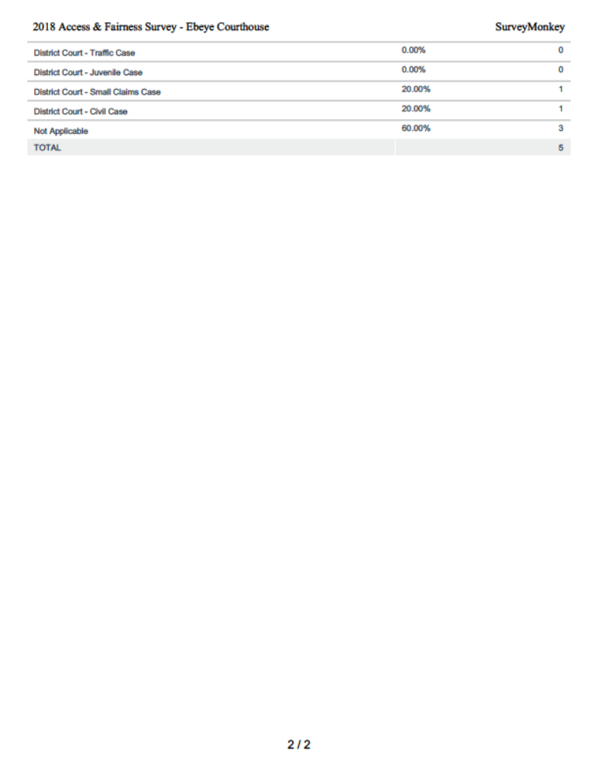
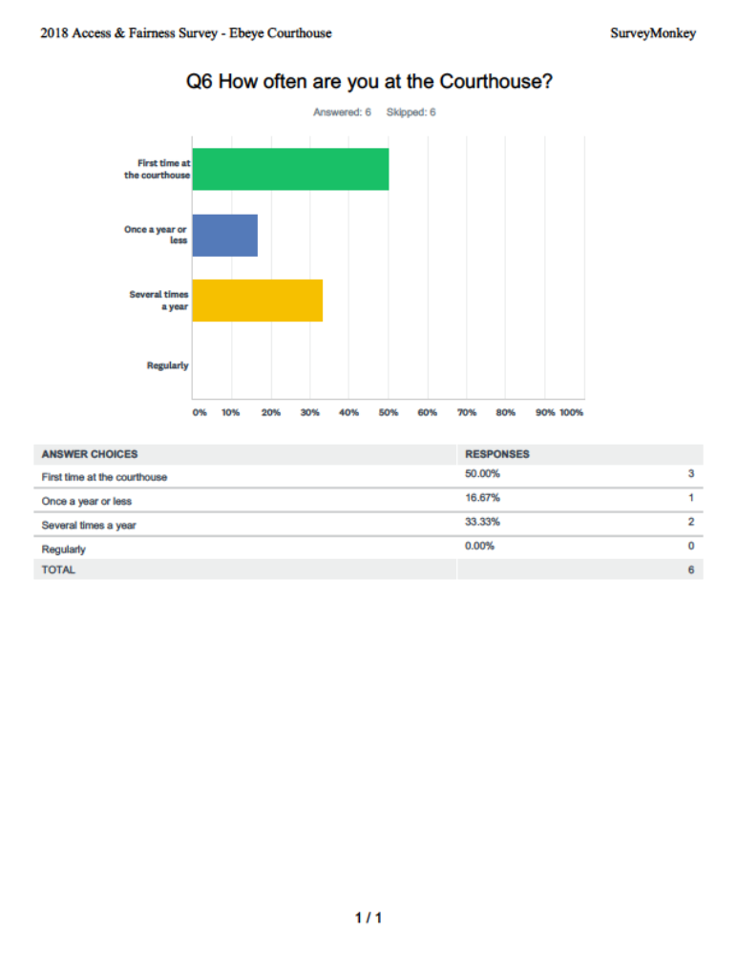
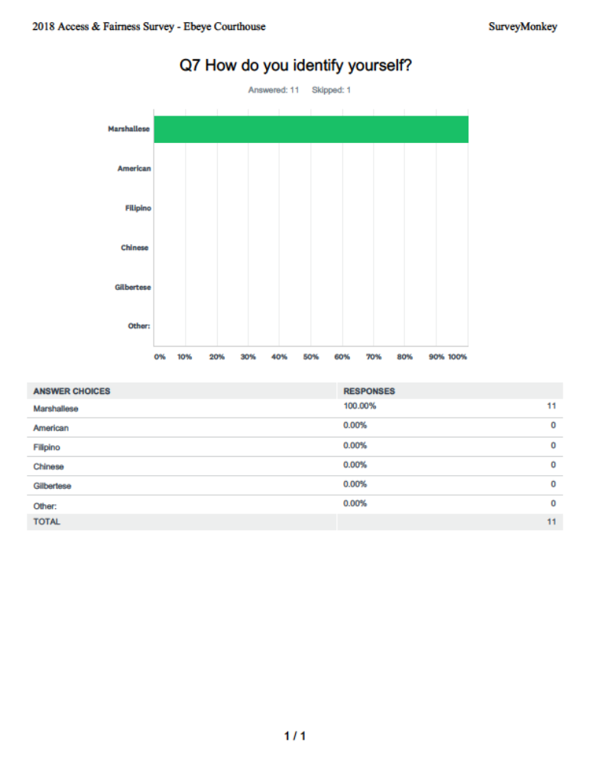
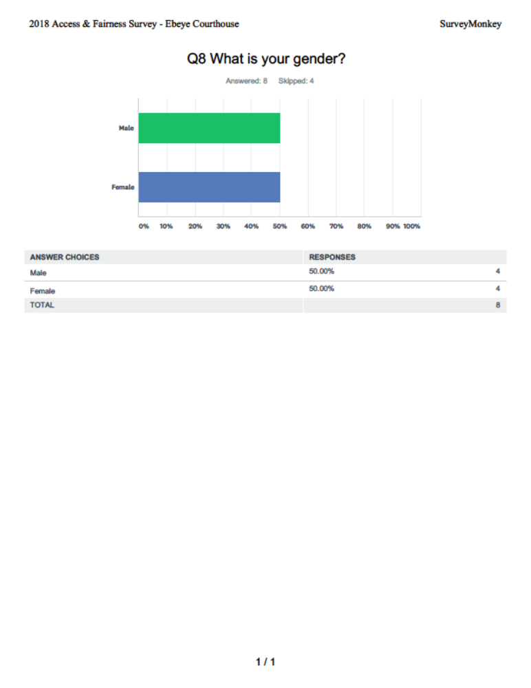
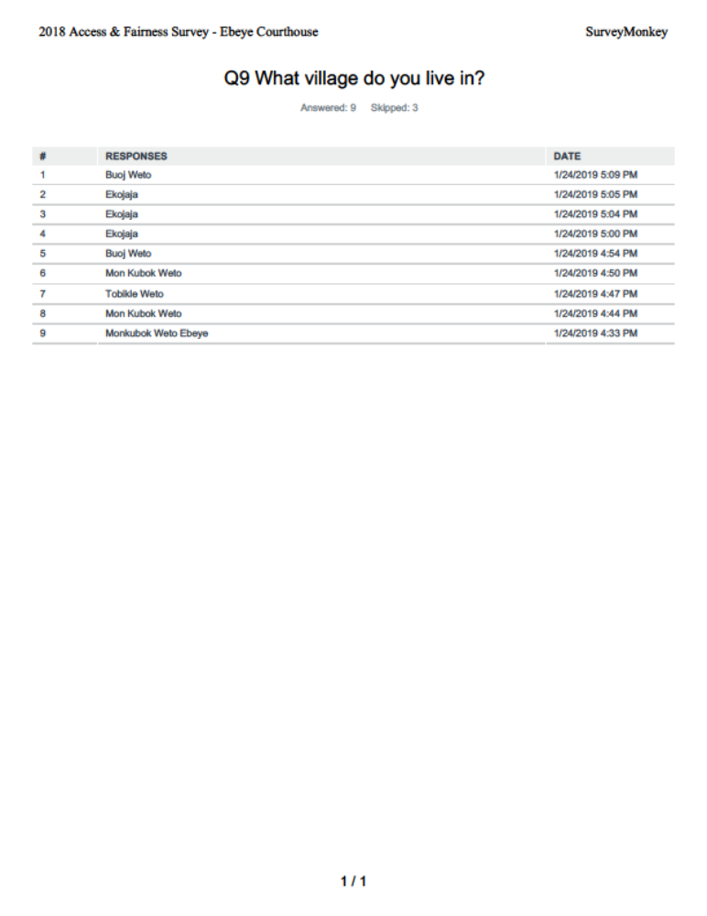
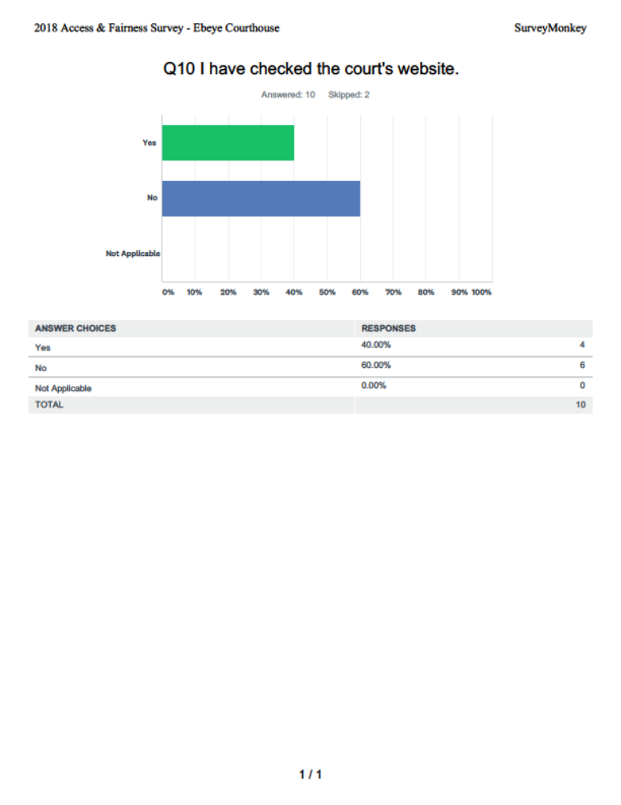
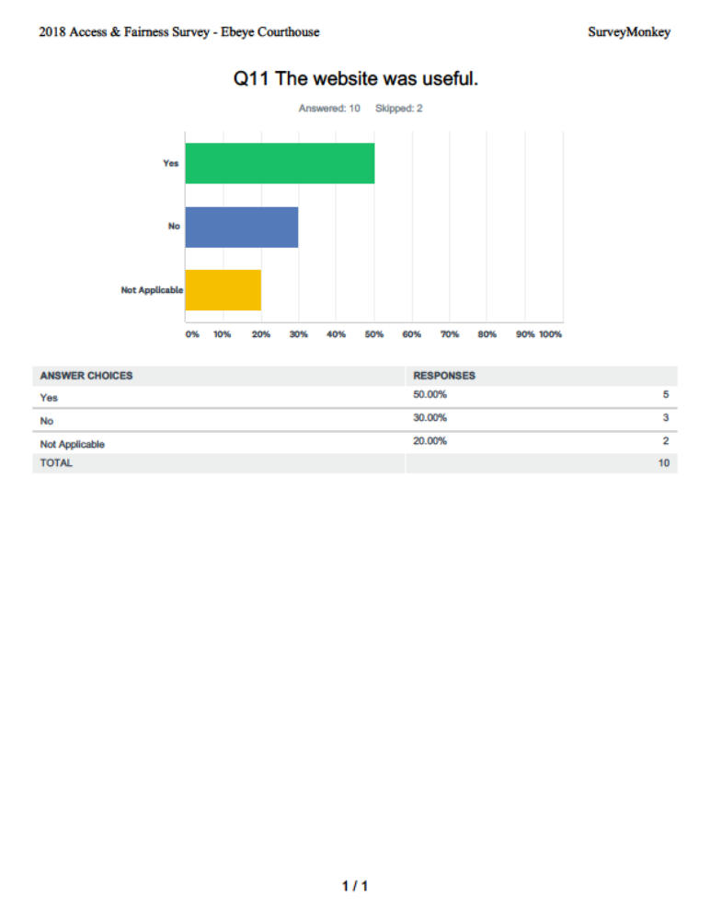
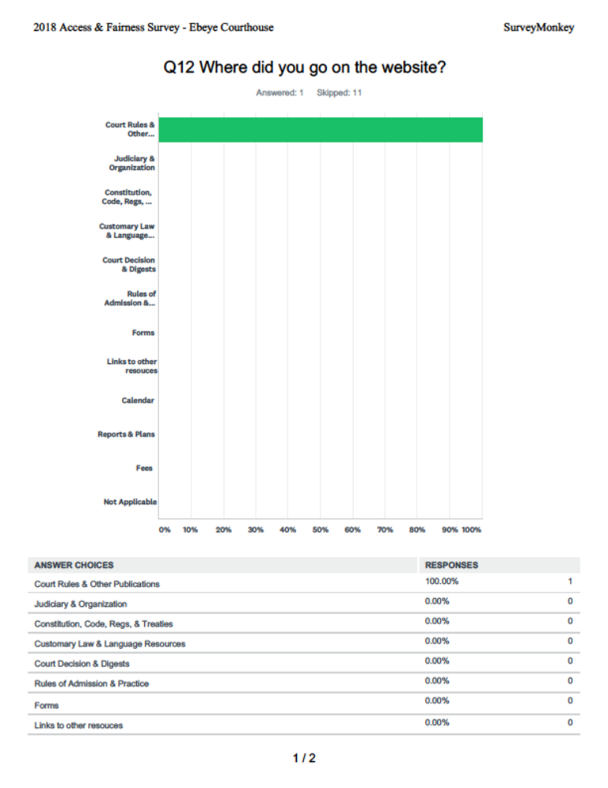
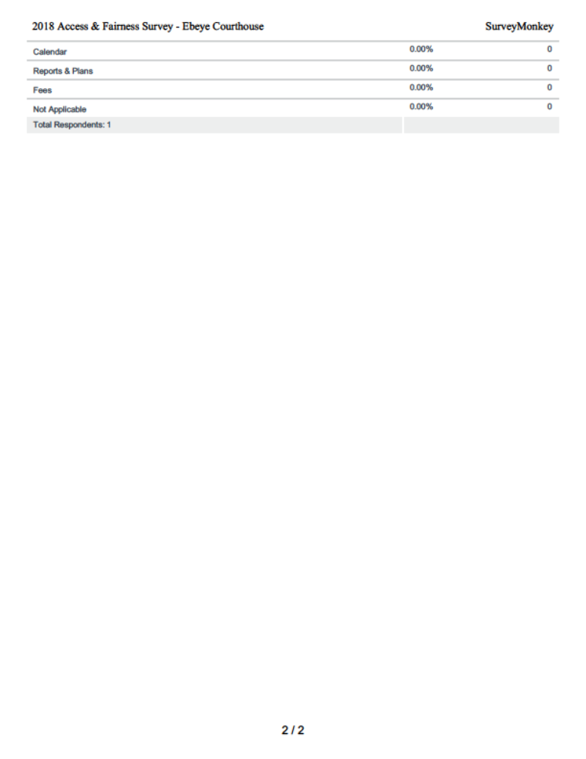
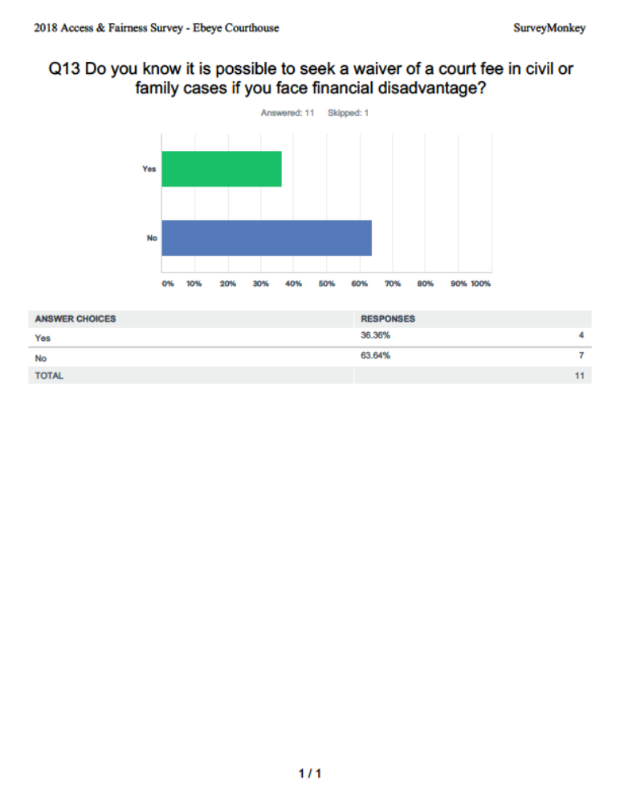
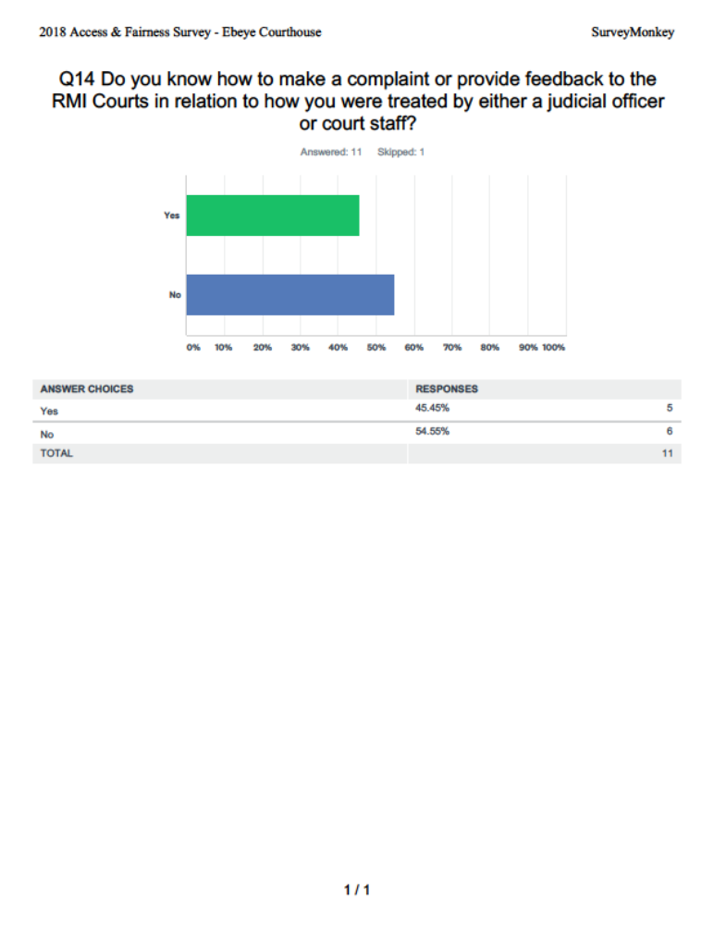
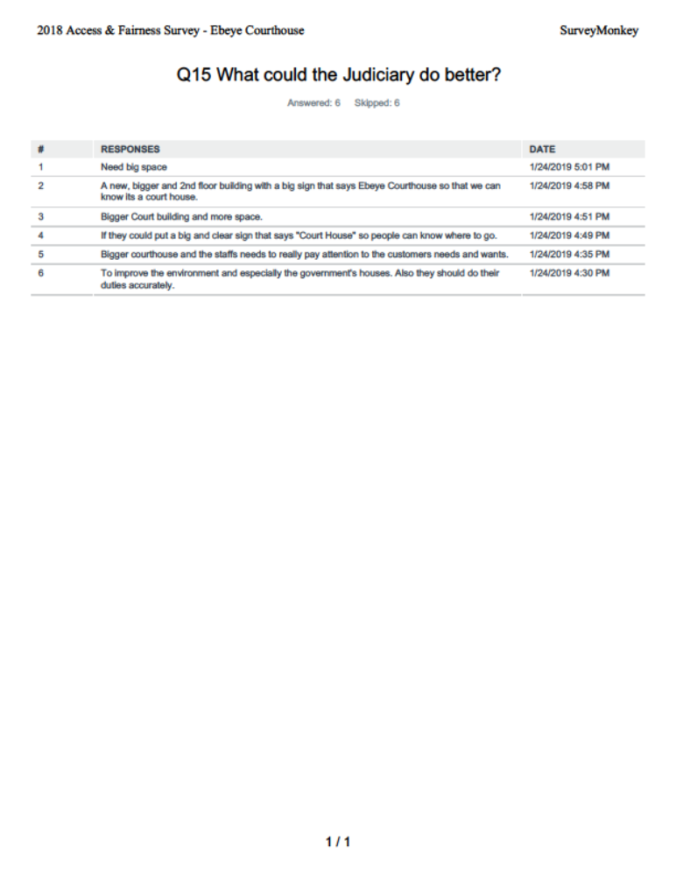

Other charges: Unauthorized sale to minors (3), Unauthorized Hours of Operation/Package Store (1), & Failure to correct sanitation standards (1).

